Concordia- PTL is proud to introduce **“Birthday Grams”!**

Parents if your child is having a birthday and you want to make it special…

Students if your friend(s) or teacher(s) is/are having a birthday and you want to help them celebrate…….

Celebrate with a “Birthday Gram”!

Here's how it works:   
-We will send home an order form at the beginning of each month (Also have extras in the office). Students, Parents, and/or Teachers will complete the order form and turn form and money into office (via Homeroom teacher for students). On the day of the persons birthday we will deliver the BDAY gram(s) to them. If the persons birthday falls on the weekend or holiday it will be delivered the day before. All details of options and cost will be on the order form.   
Items Sold:

Suckers……………....$2.00

Balloons……………...$3.00

Arrangements……….$10.00

**Since we are starting so late in the year with this project we will back date all birthdays from July 1st- October 31 in the month of October. We want EVERYONE to feel special!!!

**Birthday Lunch**

We will celebrate students with birthdays in October tomorrow Wed. October 12th. Parents and family members are welcome to join their child(ren) for lunch. If you would like to purchase a school meal, please let the office know by 9:00 a.m. *NO FAST FOOD OR SOFT DRINKS ARE ALLOWED.*

*Lunch Times:*

*4th – 8th 11:25 am*

*Prek - 3rd 11:45 am*

**10/10 – Columbus Day - NO BUS**

**10/10 – Start Birthday Candy Grams**

**10/12 – October Birthday Lunch**

**10/12 – Volleyball at Concordia 4:45 p.m.**

**“Concordia v. St. Paul”**

**10/13 – Chapel at 2:45 p.m.**

**10/13 – Soccer Meeting Parents & Players**

**4:00 p.m. in the gym**

**10/14 – End of First Quarter**

**10/14 – PTL Capri Sun Dress Down $1.00**

**10/15 – Attic Attack Part II 9:00a.m.**

**DATES TO REMEMBER:**

**10/18 – PTL Meeting 6:00 p.m.**

**10/24 – 10/28 Halloween Candy Grams**

**10/26 – NO Morning BUS, JP Late Take In**

**10/27 – Texas Road House Night**

**10/28 – Picture Retakes**

**10/28 – Pre-K – 4th Grade Field Trip**

**“Pumpkin Patch”**

**10/28 – Movie Night 6:00 p.m.**

**10/31 – Trunk –A– Treat 1:30 p.m.**

**October Birthdays**

***Christen Clark 10/02/2004***

***Kesean Howard 10/03/2010***

***Hayden Flynt 10/05/2011***

***Wyatt Greene 10/10/2004***

***Mathew Bonvillian 10/11/2007***

***Aubree Velazquez 10/13/2006***

***Havyn Holmes 10/18/2002***

***Cassie Reed 10/19/2004***

***Ja-vier Francis 10/20/2003***

***Danae Williams 10/24/2007***

“Your word is a lamp for my feet and a light on my path.” Psalm 119:105

# HAPPENING THIS WEEK

October 10, 2016

Volume 9

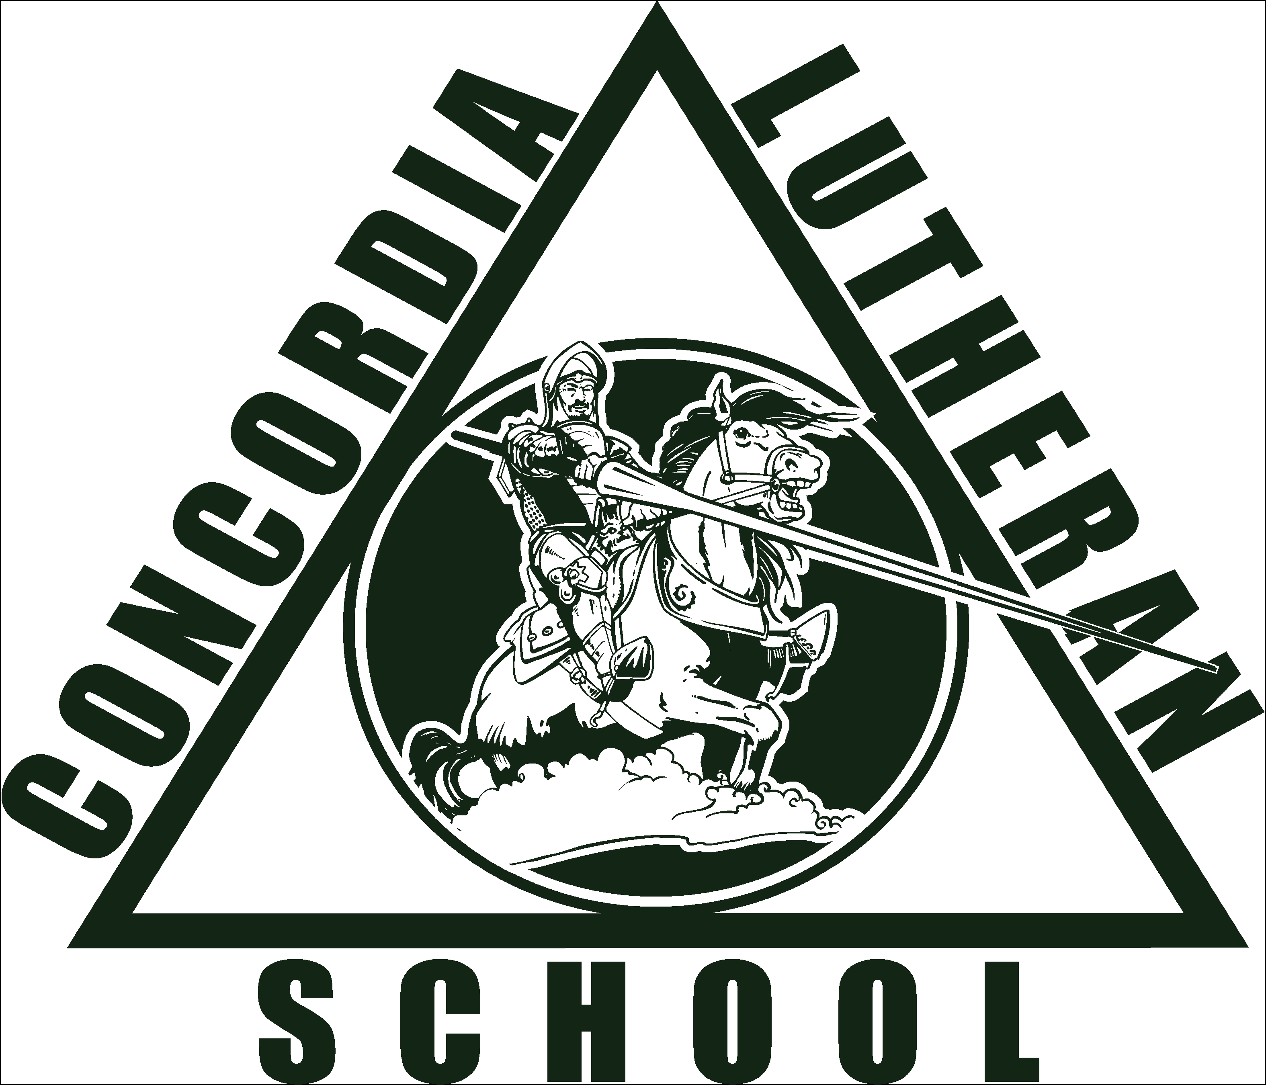

A caption describing the graphic

The Crusader News

banner with apples and crayons

The team participated in the Lutheran Jr Jamberry this weekend. CLS won 1 of the 3 games, but played very well. Great job girls!!

The Jr’s next game is Thursday, Sept 17 @ St. John at 4:30

Both teams will play Sept 18 @CLS against St. Paul, Jr’s will start at 4:15.

**VOLLEYBALL**

## FLAG FOOTBALL

The team had a victory for their 1st game against Victory Christian. Awesome job boys!!

The next game is Wed., Sept. 16 against Kehoe France at 4:00.

GO CRUSADERS!!

Jacob Blanchard

Jonathan Burnside

Mark Bourgeois, Jr

Durlin Dixon

Dashone Dunomes

Briley Hohensee

Ja’Kwan Jones

Corey Lambert, Jr

Gavin Lambert

David Rigney

Samuel Smith

Blake Villemarette

**Sr. Team**

Zoie Balser

Alaina Bergeron

Heidy Evans

Hope Hebert

Havyn Holmes

Jasmine Porche

Cassie Reed

**Jr. Team**

Christen Clark

Sarah Collins

Asia Davis

Hailey Demers

Kamryn Harris

Cassie Reed

Moira Rigney

Semaj Smith

Jhayde Thomas

# ROOM MOTHERS MEETING

# FROM THE PRINCIPAL’S ESK

Flag Football Schedule September

3rd- vs St Edwards 10th- vs Victory Christian

Sr. 4 and 6 Sr. 4:30

Jr. 5

11th- vs Mary Magdalen

12th- Lutheran Jr Jamberry Sr 4:30

@ Faith 9AM

16th- vs Kehoe France

14th- @Kehoe France Sr 4:30

Jr. 4

Sr. 5 22nd- @Atonement vs St Paul

Sr 4:30

17th- @St John

Jr. 4:30 23rd- @ Atonement

Sr 4:30

18th- vs St Paul

Jr. 4:15 29th- vs Kehoe France

Sr 5:00 Sr 4:30

**The Crusader News Page 2**

**Attic Attack Part II**

Calling all moms, dads, aunts, uncles, grandparents, family members and friends. This Saturday, October 15, 2016 at 9:00 a.m. we will be cleaning and organizing the attic again. If you need service hours this is a great opportunity. Lunch and refreshments will be supplied.

**Halloween Candy Collection**

Trunk-A-Treat is fast approaching. We are collecting bags of candy to supply this event. Students are to turn in their candy to their homeroom teacher.

Candy- bring in "one big"(1LB-2LB-min $5value) bag of candy for dress down pass OR -bring in "two big"(1LB-2LB- min $10value) bags of candy for dress down pass and service hour(s).   
In order to get service hour(s) please send in your receipts. 





**Soccer Co-ed Sign Up!**

Parents and players, this Thursday, October 13, 2016 at 4:00 p.m. Coach John Hebert will hold a meet and greet in the gym to go over the rules and guidelines for this coming soccer seasons.

Any student in grades 4th thru 8th interested in playing soccer, boy or girl, needed to attend this meeting with their parent.



**Basketball Sign Up!**

This year Concordia will have a boys and girls teams. Coach Stewart McCall will coach the boys and Coach Phyllis Duckett the girls. Any students interested in signing up should see Coach Ashley at their scheduled P.E. time. Parents keep a look out in your fast direct, a parent and player meeting will be scheduled soon.

Dear Parents,

The Teachers and Staff at Concordia would like to send out a huge “thank you” to all the parents who came out Saturday, October 1st, to clean the attic and help with repairs. Parents generously gave up their Saturday and worked, as team for 6 hours cleaning, moving, organizing, laughing, joking, and getting to know one another. A good time was had by all and what a difference was made.

Special thanks to the dedicated parent that pulled it all together, Mrs. Monique Gueringer. She has worked tirelessly organizing the teachers’ lounge and now the attic. Again, thank you all, your support is what makes Concordia a success!

Join us for Attack the Attic, part 2 on the morning of Saturday, October 15, 2016.

Yours in Christ,

Concordia Teachers and Staff