**December Birthdays**

**Braysen Smith 12/01/2010**

**Adalynn Ledet 12/07/2009**

**Elise (Adriana) Nicosia 12/07/2003**

**Cameron Kendrick 12/11/2006**

**David Rodriquez 12/15/2005**

**Nigel Whitehead 12/15/2003**

**Jaila McCoslin 12/21/2007**

**Chelsie Heine 12/26/2002**

**Trae’Shaun Orellana 12/29/2009**

**12/05- Concordia Classified Ads Begins**

**12/05- Santa’s Workshop Opens**

**12/06- Chick-fil-la Night**

**12/07- 1st Men’s Club Meeting 6:00PM**

**12/09- Santa’s Workshop Ends**

**12/09- Breakfast and Photos with Santa**

**12/09- Concordia Rewards Store Opens**

**DATES TO REMEMBER:**

**12/11- Candy Cane Grams Begin**

**12/14- December Birthday Lunch**

**12/15- Holiday Performance 7:00 PM**

**12/16- K-5th Girl Scout Meeting 4PM**

**12/16- Family Game Night**

**12/19- Christmas Caroling at Wynhoven Nursing**

**Home Field Trip (Pre-k, Kindergarten, &**

**5th Grade)**

**12/19- Texas Roadhouse Night**

**12/21- Christmas Parties 11:00AM Dismissal**

**12/21- NO AFTERNOON EDP**

**12/22- 01/03 Christmas Holiday**

**01/05- PTL Meeting**

# HAPPENING THIS WEEK

[](http://www.polyvore.com/rainbow_lollipop_candy_look_sleek/thing?context_id=1384096&context_type=lookbook&id=185108)

**Birthday Grams**

PTL Birthday Grams are available for **ALL DECEMBER birthdays through December 20th.** Place your order now! Order forms are in the office and can be placed at any time.

**Grams can be purchased for you, your friend and/or your family members.**

Suckers for $2.00 Each

Mylar Balloons for $3.00 Each

Or

A special birthday Bouquet

Arrangement for $10.00 each

**Concordia Spirit Magnets**

PRE ORDERS are happening NOW!

Place your orders NOW!

**Magnets are $12 each** however

**During Pre-order we are having a**

**Sale "2 for $20".**

Get dem now!!

If you did not get your order form, we have extras in the office.

**Concordia Rewards Store**   
Parents as a reminder we will have the store open every Friday during lunch. If you want to have your child go shopping in the store please make sure they have their money with them or send it to the office so we can hold for them.   
  
We have a variety of items in the shop. Many fun school supplies, toys, and Candy. **Also as a reminder dress down passes are worth $.50 each in the store. Trade them in now!**

If you are interested in volunteering to help in the store please let me know.   
Thanks for your support!!

“Your word is a lamp for my feet and a light on my path.” Psalm 119:105

December 6th, 2016

Volume 15



A caption describing the graphic

The Crusader News

banner with apples and crayons

**The Crusader News Page 2**

The team participated in the Lutheran Jr Jamberry this weekend. CLS won 1 of the 3 games, but played very well. Great job girls!!

The Jr’s next game is Thursday, Sept 17 @ St. John at 4:30

Both teams will play Sept 18 @CLS against St. Paul, Jr’s will start at 4:15.

**VOLLEYBALL**

## FLAG FOOTBALL

The team had a victory for their 1st game against Victory Christian. Awesome job boys!!

The next game is Wed., Sept. 16 against Kehoe France at 4:00.

GO CRUSADERS!!

Jacob Blanchard

Jonathan Burnside

Mark Bourgeois, Jr

Durlin Dixon

Dashone Dunomes

Briley Hohensee

Ja’Kwan Jones

Corey Lambert, Jr

Gavin Lambert

David Rigney

Samuel Smith

Blake Villemarette

**Sr. Team**

Zoie Balser

Alaina Bergeron

Heidy Evans

Hope Hebert

Havyn Holmes

Jasmine Porche

Cassie Reed

**Jr. Team**

Christen Clark

Sarah Collins

Asia Davis

Hailey Demers

Kamryn Harris

Cassie Reed

Moira Rigney

Semaj Smith

Jhayde Thomas

# ROOM MOTHERS MEETING

Flag Football Schedule September

3rd- vs St Edwards 10th- vs Victory Christian

Sr. 4 and 6 Sr. 4:30

Jr. 5

11th- vs Mary Magdalen

12th- Lutheran Jr Jamberry Sr 4:30

@ Faith 9AM

16th- vs Kehoe France

14th- @Kehoe France Sr 4:30

Jr. 4

Sr. 5 22nd- @Atonement vs St Paul

Sr 4:30

17th- @St John

Jr. 4:30 23rd- @ Atonement

Sr 4:30

18th- vs St Paul

Jr. 4:15 29th- vs Kehoe France

Sr 5:00 Sr 4:30



[](https://www.google.com/url?sa=i&rct=j&q=&esrc=s&source=images&cd=&cad=rja&uact=8&ved=0ahUKEwik0-zPnMzQAhXB4CYKHbjZBvoQjRwIBw&url=https://www.pinterest.com/red_hussar78/christmas-graphics/&psig=AFQjCNEgoSijur0oc9jWuLSpaygmJY7vLQ&ust=1480449026663595)

**Breakfast and Photos with Santa**

**Friday, December 9th**

Place your Breakfast order now! Breakfast will start at 8:30am on Friday morning. All members of your family are welcome for a fun and memorable event. Hope Photography will be onsite for pictures with Santa. Breakfast order forms are attached to this newsletter or you can get one in the office.

**Santa’s Workshop**

**December 5th – 9th**

Students will be able to shop and purchase gifts Monday through Thursday during their scheduled times. On Friday, December 9th after breakfast and photos with Santa the workshop will open for parents and students to do last minute shopping (together).   
  
The list of times assigned for each grade level are as follows:

8:45 6th & 7th Grade

9:15 2nd Grade

9:45 5th Grade

10:15 3rd Grade

10:45 Pre-k & Kindergarten

11:15 8th Grade

12:45 4th Grade

1:15 1st Grade

We still need parent volunteers for each day of this week to run the store, set up and break down shop.

Please let Monique Gueringer know if you can volunteer.

**Double Feature**

[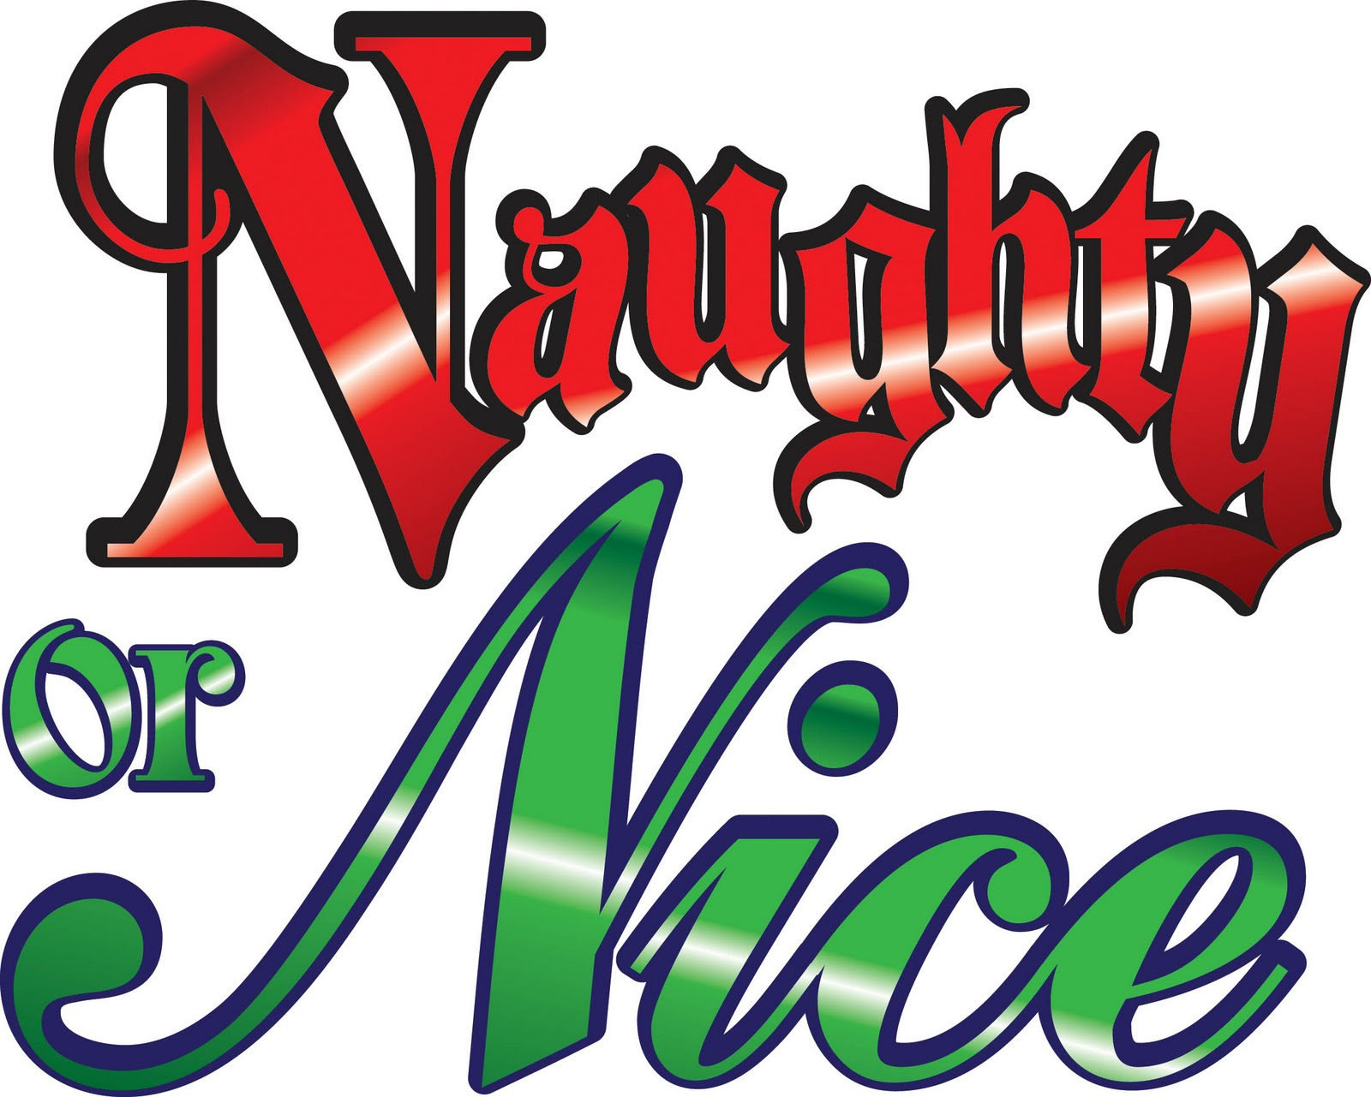](https://www.google.com/url?sa=i&rct=j&q=&esrc=s&source=images&cd=&cad=rja&uact=8&ved=0ahUKEwiouJmEn8zQAhWHdSYKHSNpCKUQjRwIBw&url=http://www.clipartpanda.com/categories/pervert-clipart&bvm=bv.139782543,d.eWE&psig=AFQjCNE5T38Uil8ogjl0eVhlxWm1O0OoNQ&ust=1480449591187230)

**Santa/Elf Post Office**

Parents you will be getting a **SEALED** letter addressed to **“PARENTS EYES ONLY”!**

Santa and The Elves have opened a Post Office at Concordia!

They will be getting reports from teachers and parents about students and will be sending home letters to them.

**Christmas Donations for our Elders**

This time of year is so important to help our children remember the joy of giving to others and loving their elders.

We will begin to collect gifts and misc. items for our visit to **Wynhoven Nursing Home** on Monday, December 19th.

*Example of such items would be: Pocket Kleenex, Grip Socks, Shaving Supplies, Puzzles, Crossword Puzzles…etc.*

We will also collect cash donations to help purchase such items. Please send donations to the office unwrapped so we can make sure we have enough gifts for the 160 residents.

Thanks so much in advance for your donations.



**The Crusader News Page 3**

**ISO (In Search Of):**

**Furniture needed....**

In preparation of our Pre K-3 class for next year we are in search of items to create activity centers along with any educational toys. If you know of anyone that is getting rid of some of these things please let them know we would be glad to use them for our new family addition!

Thank you!

[](https://www.google.com/url?sa=i&rct=j&q=&esrc=s&source=images&cd=&cad=rja&uact=8&ved=0ahUKEwjky7jkyavQAhXE5SYKHR5zBAYQjRwIBw&url=http://www.cowetaschools.org/jpes/index.php/parentinfo/pre-kindergarten-information&bvm=bv.138493631,d.eWE&psig=AFQjCNFlLeyysmWRmDeBiwA9TDBuX8r7Tw&ust=1479327182944775)

**2017-2018 PK3 Class Waitlist**

It’s Official… Next school year we will add PK3 to our school enrollment! We are starting a waitlist now. If you know of anyone interested please have them contact the school…. First come, first serve.

PLUS if you refer someone….

**Refer A Friend Program $$$**

Concordia Lutheran School is proud to introduce.... "Refer-A-Friend" program!   
Concordia will take $100 off of your child's tuition for each new student that is brought into the school.   
  
***NOTE:*** This program is going forward and not retroactive. For any new referred student enrolled into Concordia as of Monday October 24th, you will be eligible to receive an incentive after new student’s fees and tuition plan has been paid.   
Referrals are limited to ten new students per school year (up to $1,000 value).   
New parent (child) must put referred person’s name on application when registering.   
  
This is an excellent opportunity to get some extra incentive for sharing our wonderful little secret! Happy referring!

**Concordia Men’s Club**

CALLING ALL DAD'S (MEN)......   
Concordia family we will have our first meeting of the Men’s (Dads) Club Wednesday, December 7th at 6pm.

The purpose of the Dads' Club is to help with projects around the school and to build friendships between families!

Please come out and meet other parents and see how you can be a part of the family!

**Girl Scouts K-5th Grade**

**ATTENTION Girl Scouts…**

The next meeting for Girl Scouts will be held on Friday, December 16th from 4-5 pm in the Library.

Please make arrangements to attend.

[](http://cs419524.vk.me/v419524583/1708/jom6yDdeFVo.jpg)

**Uniform Sale**

New outdated uniforms and gently used uniforms are available for purchase for only $2 each.



**The Crusader News Page 4**

**From the Coach’s Desk**

Please write your child(rens) name inside of their uniforms, jackets, sweatpants, sweatshirts, etc. There has been a large amount of these items left in the gym and around school. If there is a name on it, we have a better chance of getting it back to the rightful owner. If there is no name, it is placed in the lost and found.

**BOYS Basketball Games**

**No Games in December!**

**Friday, January 6th at 4:30 @ Concordia**

Come out and represent our boys!

**Pep Squad**

**Performs at HOME Games ONLY!**

**Practice is on Tuesday and Wednesday from 4pm- 5pm**

If you are in 1st or 2nd grade and are interested please get with Coach Carla Greene TODAY!

**Cheerleaders**

**Practice is on Tuesday from 4pm – 5pm**

Questions?

Please contact Coach Kelly, Coach Jade and Coach Henderson

[](https://www.google.com/url?sa=i&rct=j&q=&esrc=s&source=images&cd=&cad=rja&uact=8&ved=0ahUKEwif0NPP3KvQAhWDWCYKHXFZA6UQjRwIBw&url=http://mbp.ch2v.com/content.asp?PageID%3D2&bvm=bv.138493631,d.eWE&psig=AFQjCNHTW3-YbKW5PLHWfyxinIiD8TRPPA&ust=1479332283351100)

[](https://www.google.com/url?sa=i&rct=j&q=&esrc=s&source=images&cd=&ved=0ahUKEwiJz4Gn3avQAhVF5SYKHbzoBO0QjRwIBw&url=http://mdpbc.com/2015/09/13/mdp-concession-volunteers-needed-for-home-football-games/&bvm=bv.138493631,d.eWE&psig=AFQjCNHTW3-YbKW5PLHWfyxinIiD8TRPPA&ust=1479332283351100&cad=rjt)

**Parents we are in need of volunteers to work the concession stand during each HOME game.**

**Service Hours are awarded for your hours worked.**

**Please sign up TODAY!!**

**The Crusader News Page 5**

**Chick-fil-a Spirit Night**

Put your pots and pans away and join us for Concordia’s Chick-fil-a Spirit Night tonight Tuesday, October 4, 2016. Tonight is Chick-Fil-A night between 4:00-8:00. If you go eat at Chick-Fil-A between these hours, let them know you are with Concordia and our school will receive a percentage of what is earned during those hours. Also, if you buy an adult meal then you will receive a child's meal for free. Come on out and support our school! [#GeauxCrusaders](https://www.facebook.com/hashtag/geauxcrusaders?source=feed_text)



**KITCHEN HELP**

**VOLUNTEERS NEEDED DAILY**

Parents, we need help in our lunchroom DAILY.

We need help with serving and cleaning. If you are available PLEASE lend a hand and help. Reach out to Mrs Kelly Macaluso- Kitchen Manger or the office for information.

**Service Hours earned** for your time!

[](https://www.google.com/url?sa=i&rct=j&q=&esrc=s&source=images&cd=&cad=rja&uact=8&ved=0ahUKEwjInKzz9q3QAhUE6CYKHX9aCz8QjRwIBw&url=http://www.litamarin.com/events-and-news.html&psig=AFQjCNHILSOab9CjTiDKs5_UjS7jsYdQ3A&ust=1479407958250894)

[](https://www.google.com/url?sa=i&rct=j&q=&esrc=s&source=images&cd=&ved=0ahUKEwiTndPv8q3QAhUDJCYKHebRBGYQjRwIBw&url=http://www.mydoorsign.com/Door-Signs/Lunch-Room-Signs.aspx&psig=AFQjCNFy58hNY3wwoupVdVQjGyvgSQEyWQ&ust=1479406953362508&cad=rjt)

**Concordia Classified Ads**

**Attention:**

* Small Business Owners
* People looking to sell and buy items
* People hosting Garage Sales

Concordia Family we are very excited to announce and advertise our weekly (newsletter) Classifieds! If you are looking to advertise your business, sell or buy something and/or having a garage sale we can help advertise for you.

For a small cost of $5 a week or $15 a month per Ad.   
Ad will run in Newsletter and will be posted on our PTL Facebook page.

[](https://www.google.com/url?sa=i&rct=j&q=&esrc=s&source=images&cd=&cad=rja&uact=8&ved=0ahUKEwiEsKXGjszQAhUDeSYKHRKnDZYQjRwIBw&url=https://www.antigotimes.com/&psig=AFQjCNGvvJjh3jUJ1TExD0oyryFs_wxweA&ust=1480445150218354)

**Principal’s Message**

Dear Parents,

I would like to thank our CLS families with all of our events this month. The students enjoyed their movie night and winter formal. Our 5th thru 8th graders have been working so hard to prepare for the Holiday Performance Thursday, December 15th night at 7:00PM. Please be safe and have a blessed holiday season. We look forward to the coming of the New Year! If you have any comments or concerns, know that my door is always open.

Yours in Christ,

Jackie Daniilidis

Concordia Principal

Concordia Family,

We share a lot of information and pictures on our PTL Facebook page. Please join now so you can stay involved and up to date with the lasted information.

Search for: **Concordia Lutheran School PTL**

[](https://www.google.com/url?sa=i&rct=j&q=&esrc=s&source=images&cd=&cad=rja&uact=8&ved=0ahUKEwib6sLVkszQAhXKfCYKHSG1DIAQjRwIBw&url=http://www.pointperformingarts.com/staff/&psig=AFQjCNGousotp-eyfVZIlQ4wZffL0tFkog&ust=1480446263312707)

**Please continue to turn in your Campbell and Community Coffee Labels. Students who turn in**

**(50) Labels will earn (1) dress down pass**.

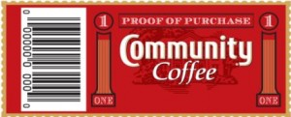



**Please continue to turn in your Coke Caps. Students who turn in**

**(50) COKE REWARD CAPS will earn (1) dress down pass**.





**Please continue to turn in your box tops. Students who turn in**

**(50) BOX TOPS will earn (1) dress down pass**.



**The Crusader News Page 6**