Parent Activation Instructions

Welcome, parents of Lebanon Lutheran School!

Please follow the instructions listed below in order to activate your account on your school's system. We here at FastDirect look forward to serving you and your child!

Step 1: Connect to the Internet.
Step 2: To access the log-in page for your school, type in the following URL
(website address): http://www.fastdir.com/lls
Step 3: On the left side of the log-in page, please click on the button titled
Parent Activation.
Step 4: Please complete the form (like the example provided below) using the activation code that was provided by the school office. Once the form is completed, press the 'Submit' button to send the information to FastDirect.
Step 5: Within 24 hours, our HelpDesk (fastdirectnotification@fastdir.com) will send you a confirmation e-mail with the subject title FastDirect School
Parent Activation. This important e-mail contains your temporary screen name and password so that you may log on to your school's FastDirect site.

Sample Parent Activation Form

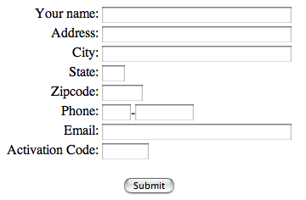

PLEASE NOTE: If the fields on the activation form (like the example above) are not completed or do not match the information on file in the school's system, an e-mail containing a temporary screen name and password will not be returned to you. In addition, some Internet Service Providers and e-mail providers may contain filters that may block delivery of the confirmation e-mail. If you do not receive your confirmation e-mail within 24 hours, please contact your school office. Thank you.

Once again, thank you for using the FastDirect system at your school. We hope that you enjoy the connection and communication it brings between parents and staff.

Sincerely,
The FastDirect team

