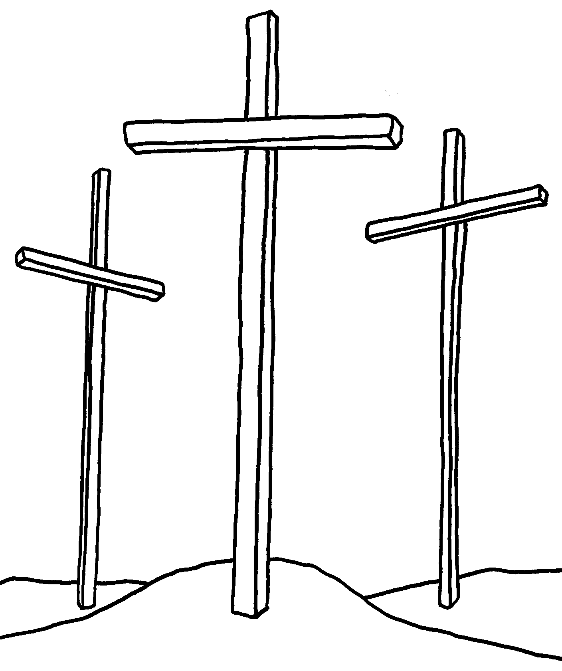

First Grade Handbook
2011-2012
Our Mission
We believe that all children are created and loved by God. First Lutheran School together with family and church educates children’s spirits, minds, and bodies in a Christ-centered environment, preparing them for Christian service and eternal life.

Bible Verse
There are several Bible verses this year for our “Standing on the Promises of God” theme.
- “For I know the plans I have for you,” declares the LORD, “plans to prosper you and not to harm you plans to give you hope and a future.” Jeremiah 20:11
- “For I am the LORD, your God, who takes hold of your right hand and says to you, Do not fear; I will help you.” Isaiah 41:13
- “When He has brought our all His own, He goes on ahead of them, and His sheep follow Him because they know His voice.” John 10:4
- “You will seek Me and find Me when you seek Me with all your heart.” Jeremiah 29:13
- “I am the way and the truth and the life. Noone comes to the Father except through Me.” Jeremiah 29:13
- “The eternal God is your refuge, and underneath are the everlasting arms.” Deuteronomy 33:27
- “In all your ways acknowledge Him and He will make your paths straight.” Proverbs 3:6
- “And we know that in all things God works for the good of those who love Him, who have been called according to His purpose.” Romans 8:28
- “For you did not receive a spirit that makes you a slave again t fear, but you received the Spirit of sonship. And by Him we cry Abba, Father.” Romans 8
- You have made known to me the path of life; You fill me with joy in Your presence, with eternal pleasures at Your right hand. Psalm 16:11
- The Lord is faithful to all his promises and loving toward all He has made. Psalm 145:13

Class Rules

Discipline Procedure

Classroom rules are posted in the front of the room. Students are expected to follow the class rules as well as the rules in the student handbook.

Consequences- students will be given a warning for any inappropriate behavior before having to face consequences. If an offense takes place later they will lose 2 minutes of recess for each offense there after. If a student loses 10 minutes of recess, they will write an apology for the offense that is to be signed and returned the next day. If your child is sent to the office for misbehaving, parents will be notified.

Because communication is a major component in your child’s education, I will be sending a sheet home each day to keep you informed on how the day was for your child. After a few weeks of daily sheets, I will start sending home a sheet weekly outlining your child’s behavior for the week.

Good Listening Rules
Eyes watching
Ears listening
Lips closed
Hands still
Feet quiet
Remember -- You are in control of you!
You are responsible for your actions!

Lunch
Lunch time begins at 11:30 and ends at 12:00. Parents are welcome to join us for lunch! Please let Mrs. Hofman or Mrs. Witt know if you plan to eat hot lunch ahead of time so our lunch count is accurate. Lunch will begin with 10 minutes of silent lunch. After silent lunch students may talk quietly to friends next to them. Students who eat hot lunch are expected to taste everything on their tray.

Snack
We will have a snack in the morning and one in the afternoon. The morning snack should be a healthy snack such as a fruit or vegetable. The afternoon snack may be a fruit roll-up, small bag of chips, or a small piece of chocolate. Students are responsible for bringing their own snack. First grade students will not be permitted to buy snack in the cafeteria, or from vending machines during school hours.

Homework
Homework has two purposes. The first and major purpose is to promote and encourage responsibility and accountability. It is your child’s responsibility to complete the assignment and return it to school on the assigned day. Failing to do so will result in your child staying in at recess time to complete the assignment. Do not try to take the blame for your child’s missing work. It is your child’s responsibility. It is your child’s homework – not mom’s or dad’s homework. This will not help teach your child responsibility, it only gives excuses. He/she needs to be responsible for completing and returning their own work.

The second purpose is to review and practice skills. Homework will be a review of the previous lessons. Homework will never be “new” information. Please work with your child every night. Research has proven that if a child reads ten minutes a day it will increase reading fluency. So, don’t forget to encourage your child to READ, READ, READ!!!

Your child will have Math homework everyday but test days. Math homework is worth 5 points. If your child turns their homework in finished and on time (the following day) they will get the full five points, if the homework is late they will receive zero points.

Your child will also have an A.R. folder that they will carry to and from school. Students will bring home the book of their choice from our class library and test on the book when they have completed the book. (If the book is too difficult for your child to read independently you may read it together, or you may read the book to them.) A.R. tests are used to test your child’s comprehension of material they are reading or having read to them, these tests do not determine your child’s reading level. A.R. is meant to get your child excited about books!

There will be some long term projects during the year that will require some work at home, but no more than 10 minutes a night. Homework in first grade should last no longer than 10-15 minutes.

Bell Work
Bell work will be done from 8:15-8:30. Bell work will help to review the subjects we are covering this year. Bell work needs to be completed every day.

Absence
- Assignments will be posted on fast direct.
- The Student will be allotted the same number of days to complete his/her work that he/she was absent. (Ex: After 5 days absence, 5 days to complete missed assignments)
- Please ask for work ahead of time for planned absences.

Show and Tell
The student of the week will take home the “Show and Tell Chest”. Show and tell will take place on Wednesday mornings during our reading block. Show and tell is a great way for students to practice public speaking. Inside the chest students will find a story stick. During show and tell they will use the story stick to help guide them through their show and tell while helping them practice story building techniques!

Reminders For a Happy Year
- Homework is to be completed and turned in the next day unless otherwise noted by the teacher.
- Memory work will be due on Friday at the end of every week.
- If it doesn’t fit in your desk, it needs to go home. Lockers are for holding jackets and backpacks.
- Check Fast Direct daily.
- Chapel services will be held on Wednesdays. Parents are welcome to attend chapel with us. Offering will be collected for missions every chapel service.
- If your child wishes to buy extra milk he/she needs to bring thirty-five cents for lunch. (or thirty five cents will be charged to your account)
- School delays - We will follow the Knox County School delay schedule as well as for school closing.
- Daily encourage your child to clean out his/her backpack and share the findings with you.
- Enjoy the loving child God has given you.

Memory Work
Memory Work will be said on Fridays. Each verse will be worth 5 points.

Memory Work
Date Verse
8-19 “For I know the plans I have for you,” declares the LORD; plans to prosper you and not
to harm you, plans to give you hope and a future.” Jeremiah 29:1

8-26 I praise you for I am fearfully and wonderfully made. Wonderful are your works.
Psalm 139:14

9-2 “For I m the LORD, your God, who takes hold of your right hand and says to you, Do not
fear ; I will help you.” Isiah 41:13

9-9 God is our refuge and strength, a very present help in trouble. Psalm 46:1

9-16 I trust in you O LORD; I say, “You are my God.” Psalm 31:14

9-23 Faith is being sure of what we hope for and certain of what we do not see.
Hebrews 11:1

9-30 We know that for those who love God all things work together for good. Romans 8:28

10-7 When He has brought out all His own, He goes on ahead of them, and His sheep follow
Him becase they know His voice.” John 10:4

10-14 “You did not choose me, but I chose you.” John 15:16

10-21 Be obedient … show perfect courtesy toward all people.

10-28 Behold , the lamb of God, who takes away the sin of the world! John 1:29

11-4 “You will seek Me and find Me when you seek Me with all your heart.” Jeremiah 29:13

11-11 When I am afraid , I will trust in You. Psalm 56:3

11-18 No Memory

12-2 I am the way and the truth and the life. No one comes to the father except through Me.
Deuteronomy 33:27

12-9 You are to love the Lord your God with all your heart and with all your soul and with all
your mind. Matthew 22:37

12-16 Love surrounds the one who trusts in the Lord. Psalm 32:10

Christmas Break

1-13 The eternal God is your refuge, and underneath are the everlasting arms.
Deuteronomy 33:27

1-20 Is it the Lord who goes before you. He will be with you … Do not fear.
Deuteronomy 31:8

1-27 The Lord is near to all who call on Him. Psalm 145:18

2-3 In all your ways acknowledge Him and He will make your paths straight. Proverbs 3:6

2-10 Oh come, let us worship and bow down; let us kneel before the Lord, our Maker!
Psalm 95:6

2-17 Give thanks o the Lord, for His steadfast love endures forever. 2 Chronicles 20:21

2-24 Be strong and courageous. Do not be frightened … for the Lord your God is with you
wherever you go. Joshua 1:9

3-2 And we know that in all things God works for the good of those who love Him, who have
been called according to His purpose. Romans 8:28

3-9 Sing to Him, sing praise to Him; tell of all His wonderful acts. Psalm 105:2

3-16 The Lord your God is with you wherever you go. Joshua 1:9

Spring Break

3-30 I am with you always, to the end of the age. Matthew 28:20

Easter Break

4-13 For you did not receive a spirit that makes you a slave again t fear, but you received the
Spirit of sonship. And by Him we cry Abba, Father. Romans 8

4-20 Trust in the Lord with all your heart. Proverbs: 3:5

4-27 Go therefore and make disciples of all nations. Baptizing them in the name of the
Father, and of the Son, and of the Holy Spirit. Matthew 28:19

5-4 You have made known to me the path of life; You fill me with joy in Your presence, with
eternal pleasures at Your right hand. Psalm 16:11

5-11 For God so loved the world that he gave his one and only son, that whoever believes in
Him should not perish but have eternal life.

5-18 The Lord is faithful to all his promises and loving toward all He has made. Psalm 145:13
Spelling Words
Spelling words are taken from our reading series. This means students will be exposed to the words in the basal readers, workbook pages, and other in class activities. We will have spelling tests on Friday. It is very important that students practice their spelling words several times before the test. To help them improve their reading and writing skills. We will not have any spelling tests for Unit 1. Challenge words are for bonus points.
Unit 2
9-23
Week 1- short a words
at, cat, an, sat, ran, man, will no
Challenge: dad, mom

9-30
Week 2- short a words
am, sad, fan, had, bad, can, find, all
Challenge: look, book

10-7
Week 3- short i words
It, hit, sick, sit, pick, kick, saw, went
Challenge: duck, black

10-14
Week 4- short i words
fix, six, him, mix, in, did, on, they
Challenge: fox, box

10-21
Week 5-Plural –s
job, dog, logs, log, dogs, jobs, this, into
Challenge: rock, frog

10-28
Week 6- short o words
hot, got, hop, not, mop, top, eat, stop
Challenge: sing, sings

Unit 3
11-4
Week 1- short e
red, fed, tell, bed, well, mess, said, who
Challenge: fell, yell

11-11
Week 2- short e
met, pet, let, get, ten, yes, want, good
Challenge: plan, trap

12-9
Week 3-short u
fun, up, stuff, run, cup, puff, jump, more
Challenge: skip, swim

12-16
Week 4- short u
us, cut, rug, bus, but, hug, our, bring
Challenge: sent, next

1-13
Week 5- Final Consonant blend
and, fast, hand, best, just, must, out, came
Challenge: sent, next

1-20
Week 6- short vowel words
clap, trip, drop, sled, spot, drum, read, please
Challenge: can’t, it’s

Unit 4
1-27
Week 1- long a
ate, gave, make, bake, late, take, as, after
Challenge: helped, wanted

2-3
Week 2- long and short a
tap, cap, mad, tape, cape, made, of, was
Challenge: check, then

2-10
Week 3- long o
rode, hope, joke, those, home, stone, has very
Challenge: shop, what

2-17
Week 4- long i
like, time, white, nice, ride, five, your, friend
Challenge: never, rabbit

2-24
Week 5- initial and final digraph
fish, such, the, long, that, with, four, were
Challenge: cute, use

3-2
Week 6- long e
we, me, see, she, he, green, any, kind
Challenge: anything, inside

3-9
Unit 5
Week 1- inflected ending –ed
ask, call, clean, asked, called, cleaned, think, only
Challenge: teach, neat

3-16
Week 2- long a= ai, ay
say, may, wait, play, way, rain, when, from
Challenge: don’t, I’m

3-30
Week 3- inflected ending –ing
grow, float, show, growing, floating, showing, old, around
Challenge: coat, yellow

4-13
Week 4- long i
lie, tie, light, night, right, been, found
Challenge: cat’s, dog’s

4-20
Week 5- vowel sounds of y
baby, many, why, funny, my, fly, even, most
Challenge: without, nobody

4-27
Week 6- ew, ue
new, drew, true, grew, blue, glue, give, put
Challenge: fixes, washes

Unit 6
5-5
Week 1- /ar/
far, star, yard, car, dark, start, work, these
Challenge: sadly, softly

5-11
Week 2- r-controlled or words
born, fork, short, for, or, torn, cold, would
Challenge: walked, sleeping

5-18
Week 3-er, ir, ur
her, hurt, first, turn, girl, bird, once, which
Challenge: slower, slowest

Week 4- ow/ou/
how, town, brown, new, down, clown, pull, goes
Challenge: paper, seven

Week 5- double consonants
Pretty, little, puppy, happy, kitten, better, took, almost
Challenge-about, round

Week 6- compound words
cannot, grandma, popcorn, outside, something, tiptoe, school, always
Challenge: boy, toy

Field Trips
Field trip dates are to be announced.
Ijams Nature Center- First Grade Animal Detectives
McClung Museum- Ancient Egypt
Seussical- Civic Auditorium- 11-1-11
Zoo Mobile
Oakes Farm
Channel 10 News

