How to Register with Cards for Kids online.
- Go to: https://shop.shopwithscrip.com
- Click Join a Scrip Program on the bottom left.
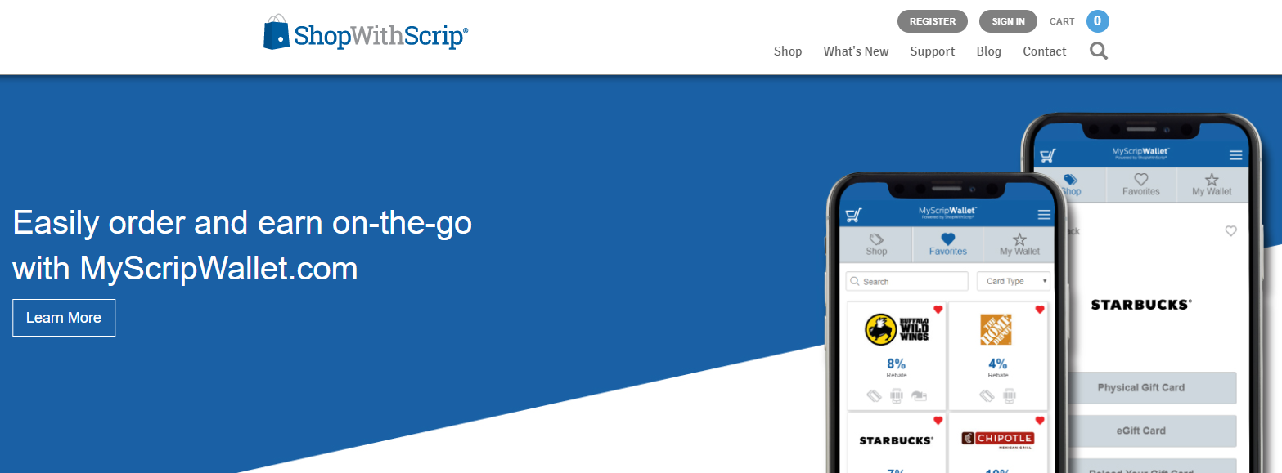
- Choose Join a Scrip Program.
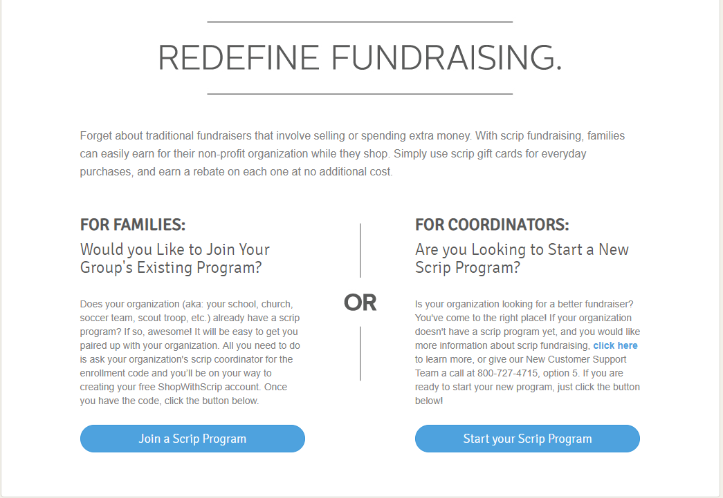

- Enter the Enrollment code: 9LCA947418L22
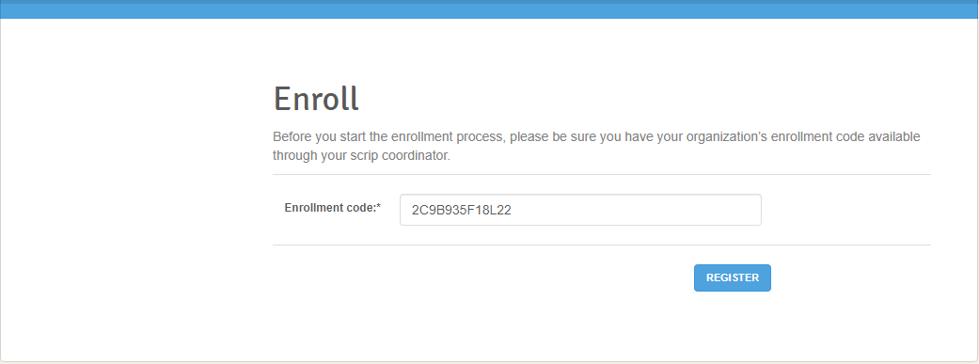
9LCA947418L22
- Fill out the registration form. Use ICOM as the Classroom/ Group
Tip: Use the name of your youngest child enrolled in ICOM (This postpones the necessity to update your profile if at all)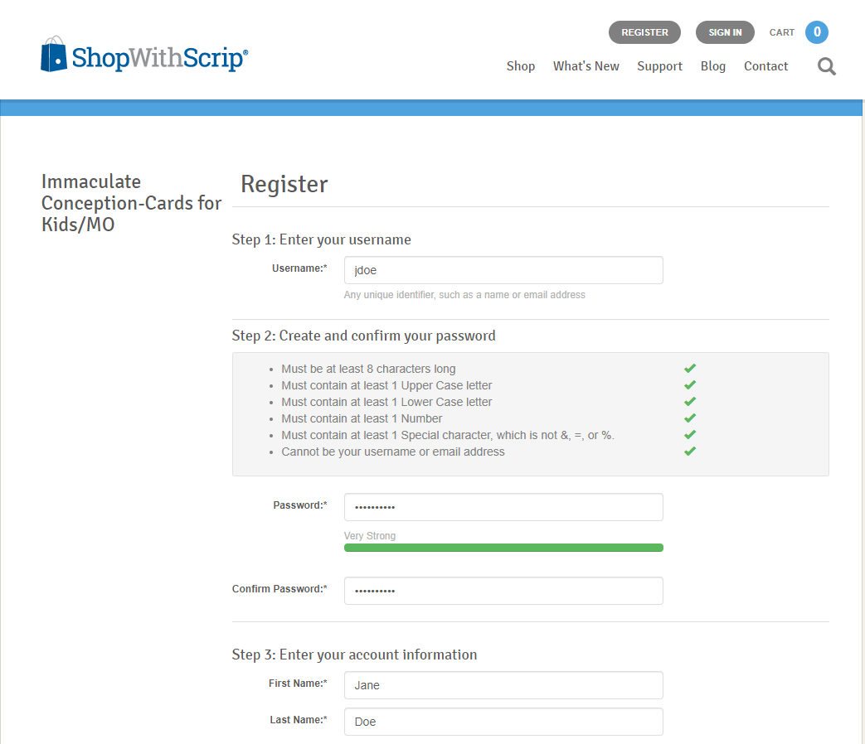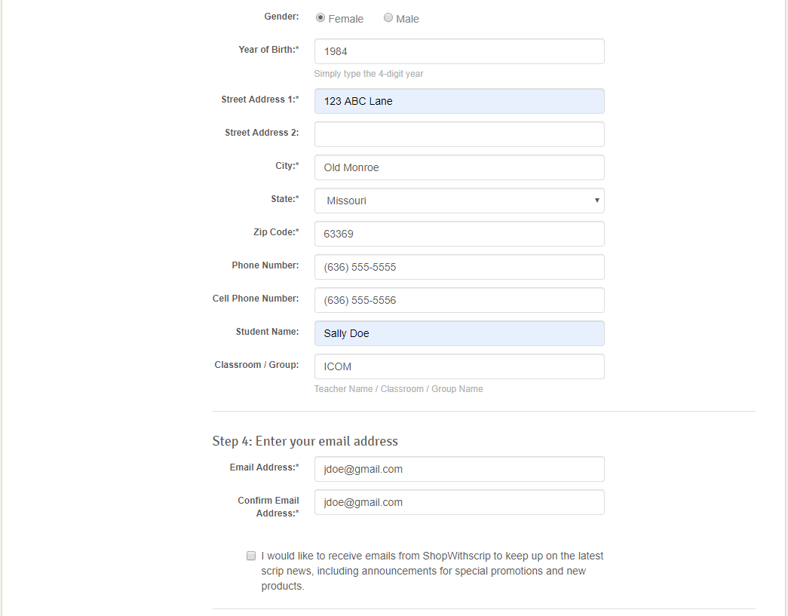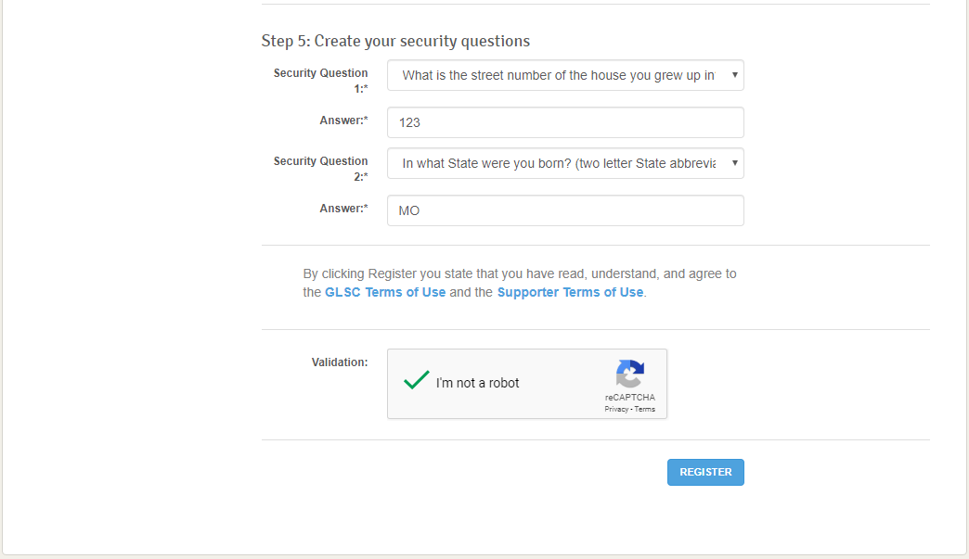
Minnie Mouse

- For security purposes you’ll need to register a phone number. You’ll want to register a number that is convenient to receive verification codes on when logging in or purchasing gift cards.
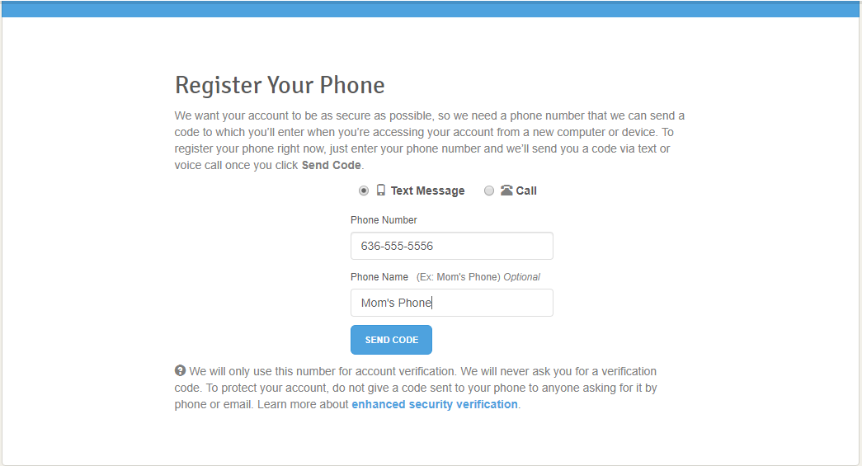
- You’ll immediately be sent a verification code on the number you enter.
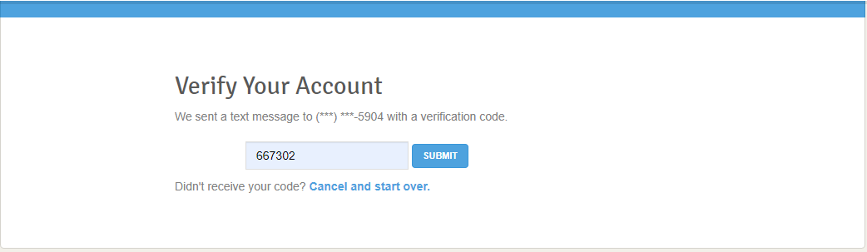
- You are now registered.
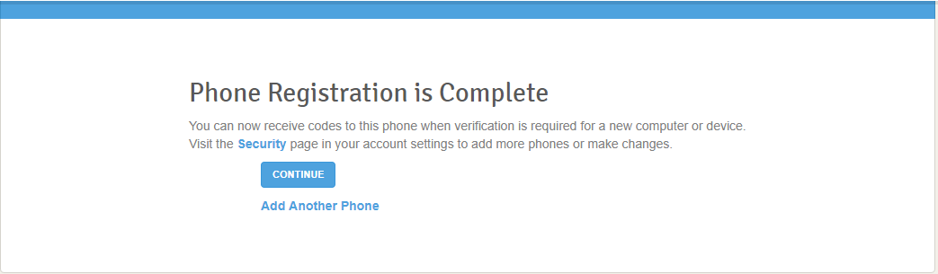

- In order to input your bank information, you’ll want to go to Dashboard at the top of the page.
- Then click payment types at the bottom of the page and follow the prompts.
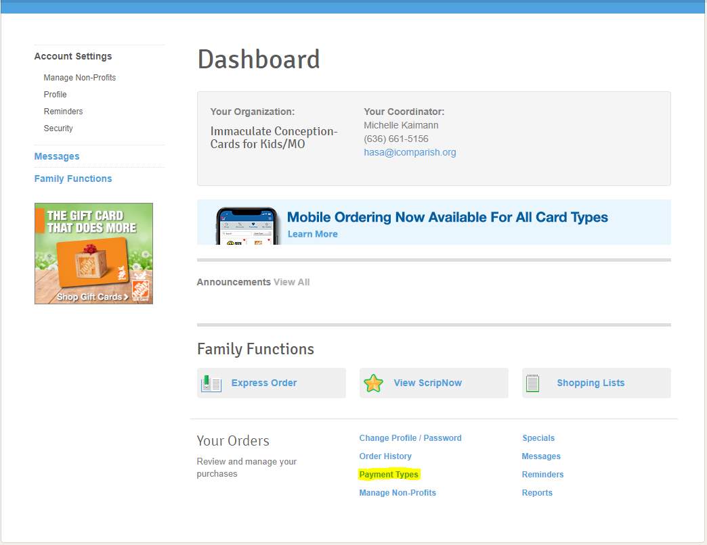
- To add the app to your phone, you’ll need to go to myscripwallet.com from your phone’s browser.
- Sign in with your Shop With Scrip Log In.
- From an iPhone, while on the web page, you can click at the bottom of your screen and choose Add to Home Screen (in the lower rows of icons and you may need to swipe left to locate).
- From an Android, while on the web page, tap on the create a bookmark icon. This is the star outline icon to the right of the URL bar. An info box should appear asking you to name the bookmark and where you want it saved. Tap on the drop-down menu. It can be found on the “Add To” choice. Tap Home Screen and you should now find the icon on your home screen.

