Spirit Shirt Order Form
ICOM 2020-2021

Parent/Guardian Name: ___________________ Best Contact #: ____________

Student’s Name: ___________________________ Grade/Teacher: ____________

Shirts are $11.00 for sizes 3T-XL. 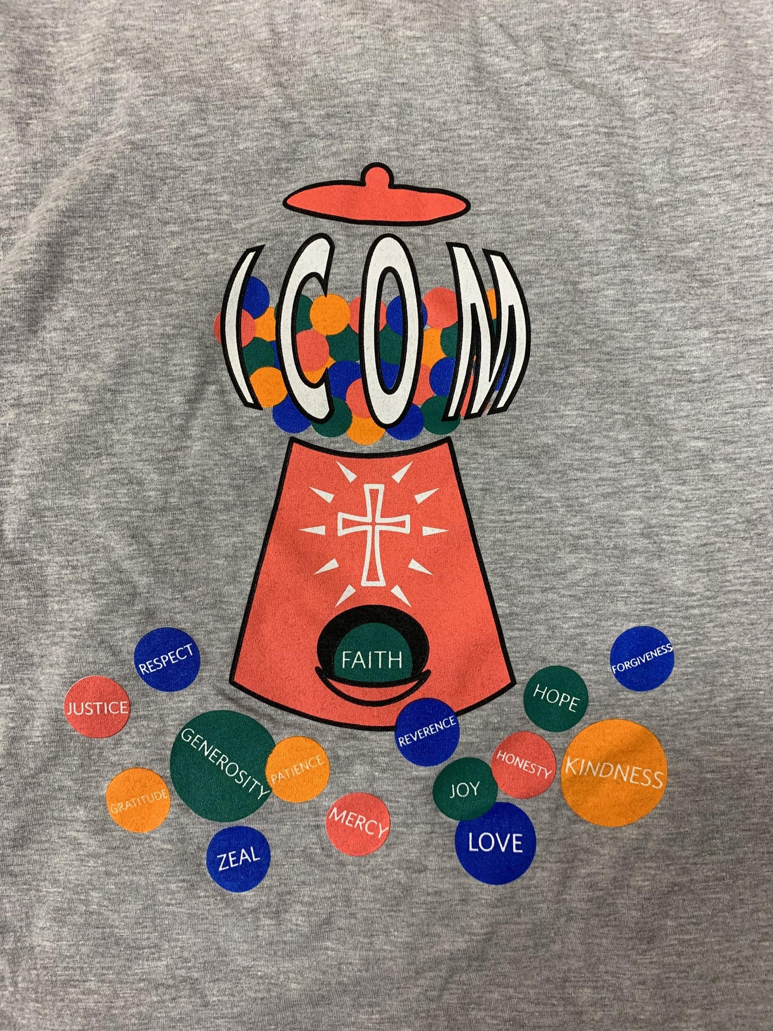

Size | Quantity
3T
4T
Youth XS
Youth S
Youth M
Youth L
Youth XL
Adult L
Adult XL
Total:

$11.00 x _______ (# of Shirts ordered) = $____________ (total cost)

Please indicate if you are paying: _________ Cash or Check #_________

