Immanuel Lutheran School
Enrollment Procedure

Thank you for your interest in Immanuel Lutheran School.

Step One: Student Enrollment Packet completed

Parent completes the following forms:
        - Enrollment Application (New students); Online Registration (Returning students)
        - Educational Fees Schedule
        - Non-refundable Registration Fee
            - $50.00 per child
        - Automatic payment plan is set up with Joyful Response
(If choosing a monthly payment plan.)
        - New Student & Parent meet with the Principal

Student is considered enrolled when all of Step One is completed.

Step Two:
A packet of school forms and information will be handed out at the Summer Registration day, August 9, 2019 or will be able to be filled out online. More information will be given when application is received.

PLEASE NOTE:
- Please use a blue or black pen or use the fill in fields to complete
- Application must be signed.

Application for Admission 2019-2020

Student Click to enter student’s First, Middle & Last Name. Grade Entering: 3K

Birth date __________________ Baptism/Dedication date _______________ Gender: ☐ Male ☐ Female
Ethnic Origin: ☐Caucasian ☐African American ☐Asian ☐Hispanic ☐Native Amer. ☐ Other

Student Click to enter student’s First, Middle & Last Name. Grade Entering: 3K

Birth date __________________ Baptism/Dedication date _______________ Gender: ☐ Male ☐ Female
Ethnic Origin: ☐Caucasian ☐African American ☐Asian ☐Hispanic ☐Native Amer. ☐ Other

Student Click to enter student’s First, Middle & Last Name. Grade Entering: 3K

Birth date __________________ Baptism/Dedication date _______________ Gender: ☐ Male ☐ Female
Ethnic Origin: ☐Caucasian ☐African American ☐Asian ☐Hispanic ☐Native Amer. ☐ Other

Student Click to enter student’s First, Middle & Last Name. Grade Entering: 3K

Birth date __________________ Baptism/Dedication date _______________ Gender: ☐ Male ☐ Female
Ethnic Origin: ☐Caucasian ☐African American ☐Asian ☐Hispanic ☐Native Amer. ☐ Other

Student Click to enter student’s First, Middle & Last Name. Grade Entering: 3K

Birth date __________________ Baptism/Dedication date _______________ Gender: ☐ Male ☐ Female
Ethnic Origin: ☐Caucasian ☐African American ☐Asian ☐Hispanic ☐Native Amer. ☐ Other

Student Click to enter student’s First, Middle & Last Name. Grade Entering: 3K

Birth date __________________ Baptism/Dedication date _______________ Gender: ☐ Male ☐ Female
Ethnic Origin: ☐Caucasian ☐African American ☐Asian ☐Hispanic ☐Native Amer. ☐ Other

Are any children adopted? ☐Yes ☐ No Who? __________________________ (If yes does the child know of the adoption?) ☐Yes ☐No

Parent Information:

Father _________________________________________________ Cell # ___________________________ Work Phone #________________
Last First Middle
Email ______________________________________________ Home Phone # ______________________________
Employer ______________________________________________ S.S #_____________________________________
Home Address: Street: _________________________________________________ City/State: __________________Zip:_______
Church Membership:________________________________________ Pastor’s name __________________________________ Denomination ________________________________ Phone _______________

Mother _________________________________________________ Cell # ___________________________ Work Phone #________________
Last First Middle
Email ______________________________________________ Home Phone # ______________________________
Employer ______________________________________________ S.S #_____________________________________
☐ Same as above- Home Address: Street: _____________________________________City/State: ________________Zip:_______
Church Membership:________________________________________ Pastor’s name __________________________________ Denomination ________________________________ Phone _______________

May we publish your home address, email address and phone number in our school directory? ☐Yes ☐No

Parents Marital Status: ☐Married ☐Single ☐Widowed ☐ Divorced* ☐ Separated* (*Complete Section Below)
*With whom does student/s reside: ☐ Mother ☐ Father ☐ Stepparent ☐Grandparent ☐Other: _______________________________
*Physical custody arrangements?_________________________________________________________________________________
*Describe legal custody arrangements (if applicable, attach necessary documents)___________________________________________

Grandparent Information: (Needed for special grandparent events in the spring)

Names: _________________________________________________________________________________ Phone: ________________________
Address: _______________________________________________________________________________________________________________
City/St:___________________________________________________________ Zip:___________ Email:__________________________________

Names: _________________________________________________________________________________ Phone: ________________________
Address: _______________________________________________________________________________________________________________
City/St:___________________________________________________________ Zip:___________ Email:__________________________________

(Continued)

Student Medical and Emergency Information:

Dismissal procedure: ☐Bus ☐ Walk ☐ Car pool ☐ Picked up by parent ☐ Other __________________________ (explain)

Please list full name of each person authorized to pick up your children:____________________________________________________________
___________________________________________________________________________________________________________________________________________________________________________________________________________________________________________

Emergency contacts if parents can’t be reached (list in order of attempt):

Name ______________________________________________ Relationship: Choose Relationship Phone ____________________

Name ______________________________________________ Relationship: Choose Relationship Phone ____________________

Family Doctor __________________________________ Phone _______________ Hospital _____________________________________

Consent & Authorization to treat: Upon my signature below Immanuel Lutheran School has my permission, in case of an emergency, to contact the proper authorities (police, ambulance, another Doctor or transport my above child/ren to the emergency room) if either my emergency contacts or I cannot be reached. I/We agree to assume any and all costs involved.

Parent(s)/legal guardian signature: _______________________________________________________________________________

Do any children have any severe allergies, physical needs or health limitations? ☐Yes ☐ No If yes, please explain including child’s name: ________________________________________________________________________________________________________________________________________________________

Do any children have any emotional or psychological needs that are currently being cared for by a professional? ☐ Yes ☐ No
If yes, please explain including child’s name: ___________________________________________________________________________________

Do any children have an identified learning difference or special needs? ☐ Yes (in the past) ☐ No

Do any children need any special prescriptions medications? ☐Yes ☐ No If yes, please :Click and or type to explain including child’s name
________________________________________________________________________________________________________________________
Do any children have an IEP (Individual Education Plan)? ☐ Yes ☐ No If yes, at which school!______________________________________

Name and address of last school attended if new to Immanuel: ____________________________________________________________________
_______________________________________________________________________________________________________________
Please Read the Following Statements and Initial:

CHRISTIAN EDUCATION
We agree to support and cooperate with Immanuel Lutheran School in its program of Christian Education. Initial _________

SCHOOL POLICIES
We will abide by all policies, rules, and regulations, striving to be a supportive part of the Christian community of students and Teachers as we work together in God’s name. Initial _________

PARENT INTERNET RELEASE
As parent or guardian of this student, I have read the Internet Use Policy in the Student Handbook. I understand that any violation of this policy is unethical and may constitute a criminal offence. I have personally discussed the agreement with my son/daughter and have made them aware of the conditions and consequences of its use/misuse. I understand that it is impossible for Immanuel Lutheran administrators, faculty and staff to monitor or restrict access to all controversial materials when students are given access to the Internet. I hereby release Immanuel Lutheran School, its operators, and any institution with which it is affiliated from any and all claims and damages of any nature which may arise from my son/daughter’s use, or inability to use this access. This approval will remain in effect during the time my child is enrolled at Immanuel Lutheran unless cancellation is submitted in writing by the parent/guardian or cancelled by the administration. Initial _________

STUDENT INTERNET RELEASE
As a student, I have read the Internet Use Policy in the Student Handbook. I will not access forbidden information and I will not try to change or modify any computer setups or programs belonging to Immanuel Lutheran School or any other facility. Should I commit any violation, my access privileges may be revoked, school disciplinary action may be taken, and/or appropriate legal action may be taken. I also understand that general student guidelines always apply. 3rd – 8th grade Student’s Initial __________

(Continued)

PUBLICITY RELEASE
I hereby grant permission for any photographs or publicity involving my child while a student at Immanuel Lutheran to be used in connection with publicity of Immanuel Lutheran School. (Please check one and initial)
☐ Permission is granted for Immanuel to use my child’s photograph or video. These pictures may be used on school bulletin boards, in the school newsletter, in local newspapers, school brochures, and also on digital media (Immanuel Church or School Website, Facebook, etc). When pictures of students are placed on digital media, personal identification will not be included.

☐ It is okay to use my child’s photograph or video as described above, except I DO NOT want any individual or group photographs of my child to be placed on digital media, including the Immanuel Church or School website or Facebook.

☐ I DO NOT give my consent to have photographs of my child used by Immanuel Lutheran School in any way.
Initial _________

Immanuel Lutheran School admits students of any race, color, national or ethnic origin to all the rights, privileges, programs, and activities generally accorded or make available to students at the school. It does not discriminate on the basis of race, color, national or ethnic origin in administration of its educational policies, scholarship, and loan programs and athletic or other school administered programs.

I the undersigned parent or guardian for and in consideration of Immanuel Lutheran School accepting my child/ren as a student/s in its school, agree to make all payments for educational fees and other necessary and normal charges in accordance with schedules for payment provided. I agree and understand that unless all payments are current, no transcripts regarding our child will be issued unless my child/ren is accepted into a school choice program. The signature below testifies to the fact that there is awareness and support of all polices found in the Immanuel School Handbook. Sign below by typing your name and giving the date. Thank you!

Parent/Guardian signature _________________________________________________Date __________________
Parent/Guardian signature _________________________________________________Date __________________

Immanuel Lutheran School
Educational Fees Schedule

Please complete, sign and return this form to the Immanuel Lutheran School office.
Mail or drop off: 1626 Illinois Avenue, Sheboygan, WI 53081
Email: schooloffice@immanuel-school.com

Parent(s) Name: Click to enter name.
Address: Click to enter name.
Phone: Home: Click to enter number. Work: Click to enter number. Cell: Click to enter number.
Email(s): Click to enter email address.
Church Membership: Click to enter name.
List student(s) enrolled for 2019-2020 at Immanuel Lutheran School
Click to enter name. (grade) Choose a grade. Click to enter name. (grade) Choose a grade.
Click to enter name. (grade) Choose a grade. Click to enter name. (grade) Choose a grade.
 |  |  | Please Check all that apply
Annual Registration Fee |  |  | ☐Yes | # of children X $50.00 per child =  $ Click to choose number of children
 |  |  | ☐No | If qualified for the WPCP Program and awarded a voucher- $0.00
Tuition Per Student |  | Member  $1350.00 (K-8) | ☐Yes | Click to choose a fee
 |  | Other Christian Fellowship $2350.00 (K-8) | ☐Yes | Click to choose a fee.
 |  | K3 - $775.00 | ☐Yes | Click to choose a fee
 |  | K4 - $875.00 | ☐Yes | Click to choose a fee
Wisconsin Parental Choice Voucher Program |  |  | ☐Yes | Will/have applied between  Feb. 1 – April 20, 2019
 |  |  | ☐No | Will/ did not apply
7th Grade Outdoor Ed fee |  |  | ☐Yes | $80.00 per child, $0 if qualified for the WPCP Program and awarded a voucher  Click to choose a fee.
Band Fees |  |  | ☐Yes | $550.00 per student ($55. Per month for 11 months). Fees will be invoiced separately.
Request for Scholarship/Tuition Assistance |  |  | ☐Yes | In order to receive any scholarship or tuition assistance, a scholarship application must be filed by August 30. Circling this box does not confirm scholarship acceptance.
 |  |  | ☐No | No assistance necessary
Multi-Student Discount |  |  | ☐Yes  Click to choose a discount. | Discount applied per additional student after first child’s paid tuition is met.
We plan to take advantage of the Early Full Payment of Fees discount | 5% of Educational fees. Not including Registration, Camp, athletics or Band Fees |  | ☐Yes | Payment is due before  September 1st  Discount will be calculated and applied when fees are paid. $_______________
Athletic Fees |  | 5/6 or 7/8 girls Volleyball | ☐Yes | Choose # of children = $Click for fee
 |  | 7/8 Girls or Boys Basketball | ☐Yes | Choose # of children = $Click for fee
 |  | 4/5/6 Boys or Girls Basketball | ☐Yes | Choose # of children = $Click for fee
 |  | 4/5/6/7/8 Cheerleading/Dance | ☐Yes | Choose # of children = $Click for fee
Educational Fee  Payment Plan |  |  | Annual, Quarterly or 12 month Payment Plans available | Click to choose a payment plan

Automatic withdrawal can be set up through the Immanuel Lutheran School Office. The ACH Joyful Response authorization form will require your bank information.

Registration fees and tuition payments can be made with a credit card but include a 3.5% service fee per transaction.
Overdue Educational Fee Policy:
- An account is overdue if payment is not received by the 25th day of the month.
- When an account is 15 days overdue, a reminder will be mailed to the home, and a $30.00 per month service charge will be added.
- When an account is 30 days overdue, another notice will be mailed to the home. Enrollment into automatic withdrawal with Joyful Response will be required.
- When an account is overdue, the student will be excluded from classes. A final notice may be sent indicating that the account will be turned over to a collection agency. A fee of 25% of the total outstanding account will be added when sent to collections or small claims court.
- Any bank returned item will result in a $75.00 fee.
(If joint legal custody, please make sure both parents/guardians sign a financial agreement form. If one parent/guardian backs out of their agreement, the other will be responsible for the full tuition cost of the child). By typing your name, you are signing this document as if signing by hand.

Click to enter name. Choose a relationship. Click to enter a date.
Signature Relationship Date

Click to enter name. Choose a relationship. Click to enter a date.
Signature Relationship Date

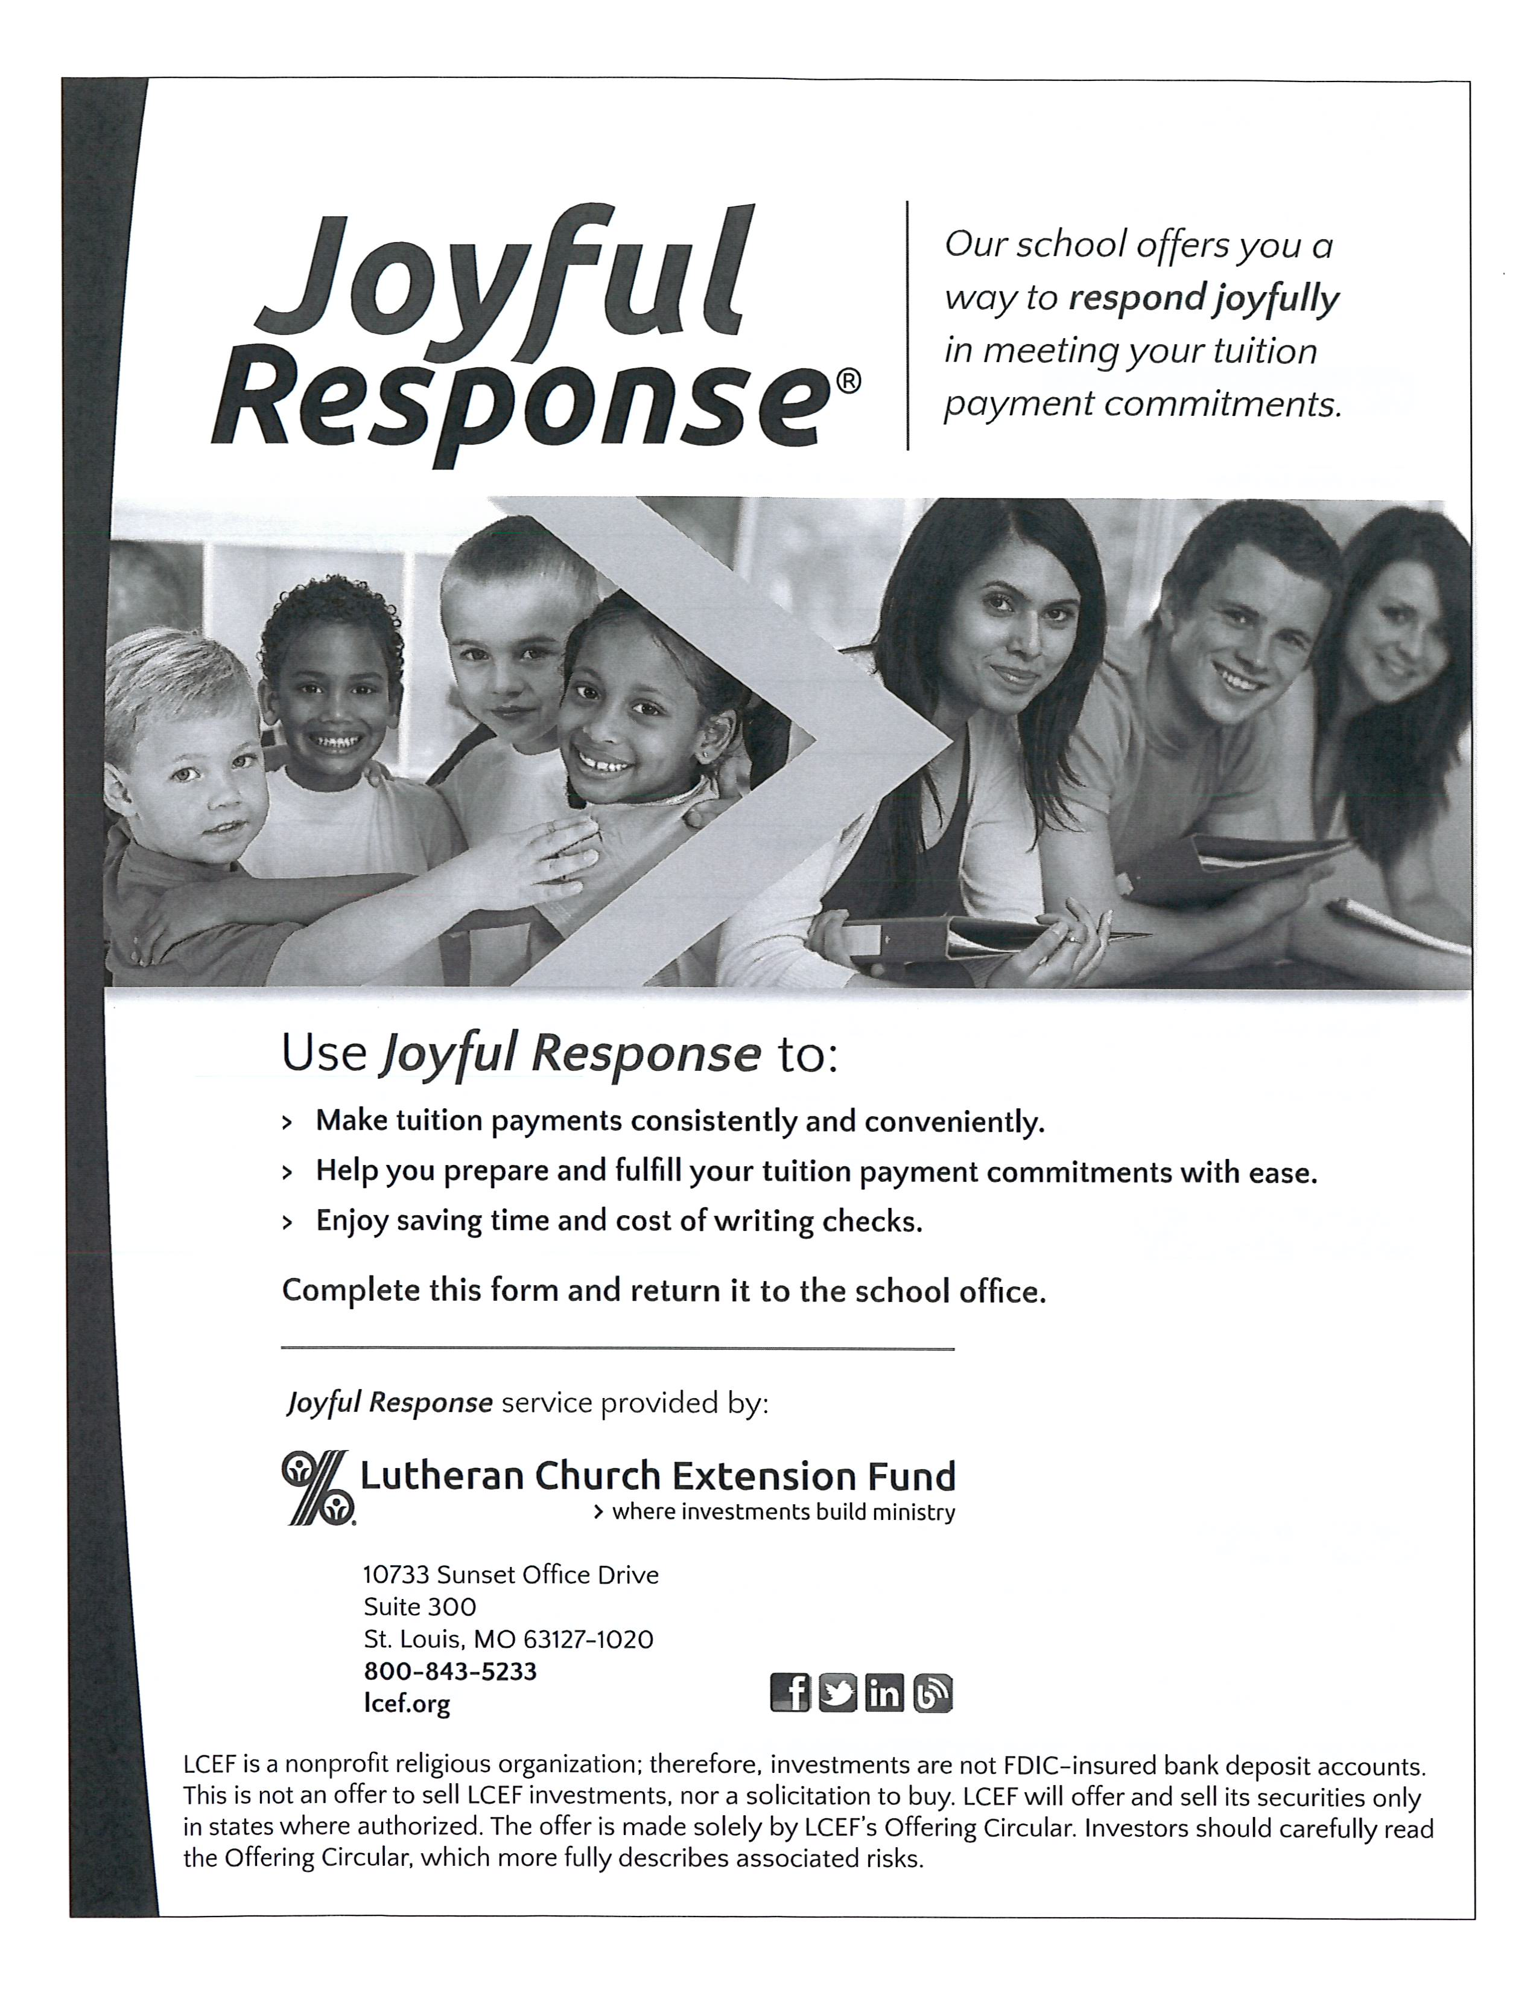
Form on Back for your convenience

Joyful Response© Electronic Tuition Payment Program

Enrollment/Change Form
Complete this form and return it to the school office to begin or change your current tuition payment. Your payments will be made automatically from your bank account or your LCEF StewardAccount.

Check the appropriate box:
☐ New enrollment ☐ Payment change ☐ Account information change
Print in Black Ink

Parent/Payer Last Name Parent/Payer First Name MI Daytime Telephone No.

_____________________________________________________________________________________________________________________________Mailing Address City, State, Zip Email Address

Student Name Grade

Student Name Grade

Student Name Grade

Student Name Grade

Student Name Grade

Click to enter information

Click to enter information

Click to enter information

Click to enter information

Click to enter information

Click to enter information

Click to enter information

My Payment Plan

Student Name Tuition Amount $

Student Name Tuition Amount $

Student Name Tuition Amount $

____________________________________________________________________________________
Total Tuition Due divided by months to Pay = $ Monthly Transfer Amount
Click here to enter information Click here to enter information
Click here to enter information Click here to enter information
Click here to enter information Click here to enter information
Click here to enter information
Debiting Account

Debit from: Transfer date (check one):
☐ Checking ☐ Monthly on the 1st
☐ Savings ☐ Monthly on the 15th
☐ LCEF StewardAccount ☐ Semi-monthly (1st and 15th)
(Half of each month’s transfer amount)
Click here to enter information
Account Number Start date: Click to enter information
Click here to enter information End date (if any):Click to enter information
Routing Number (First nine numbers in bottom left-hand corner of check)
Authorization

I authorize the above-name organization to process debit entries from my account. This authority will remain in effect until I give reasonable notification to terminate this authorization or until the last specified payment date. By typing my name, I am signing this document as if signing by hand.
Click here to sign. Click to enter a date.
_______________________________________________________________________________________________

