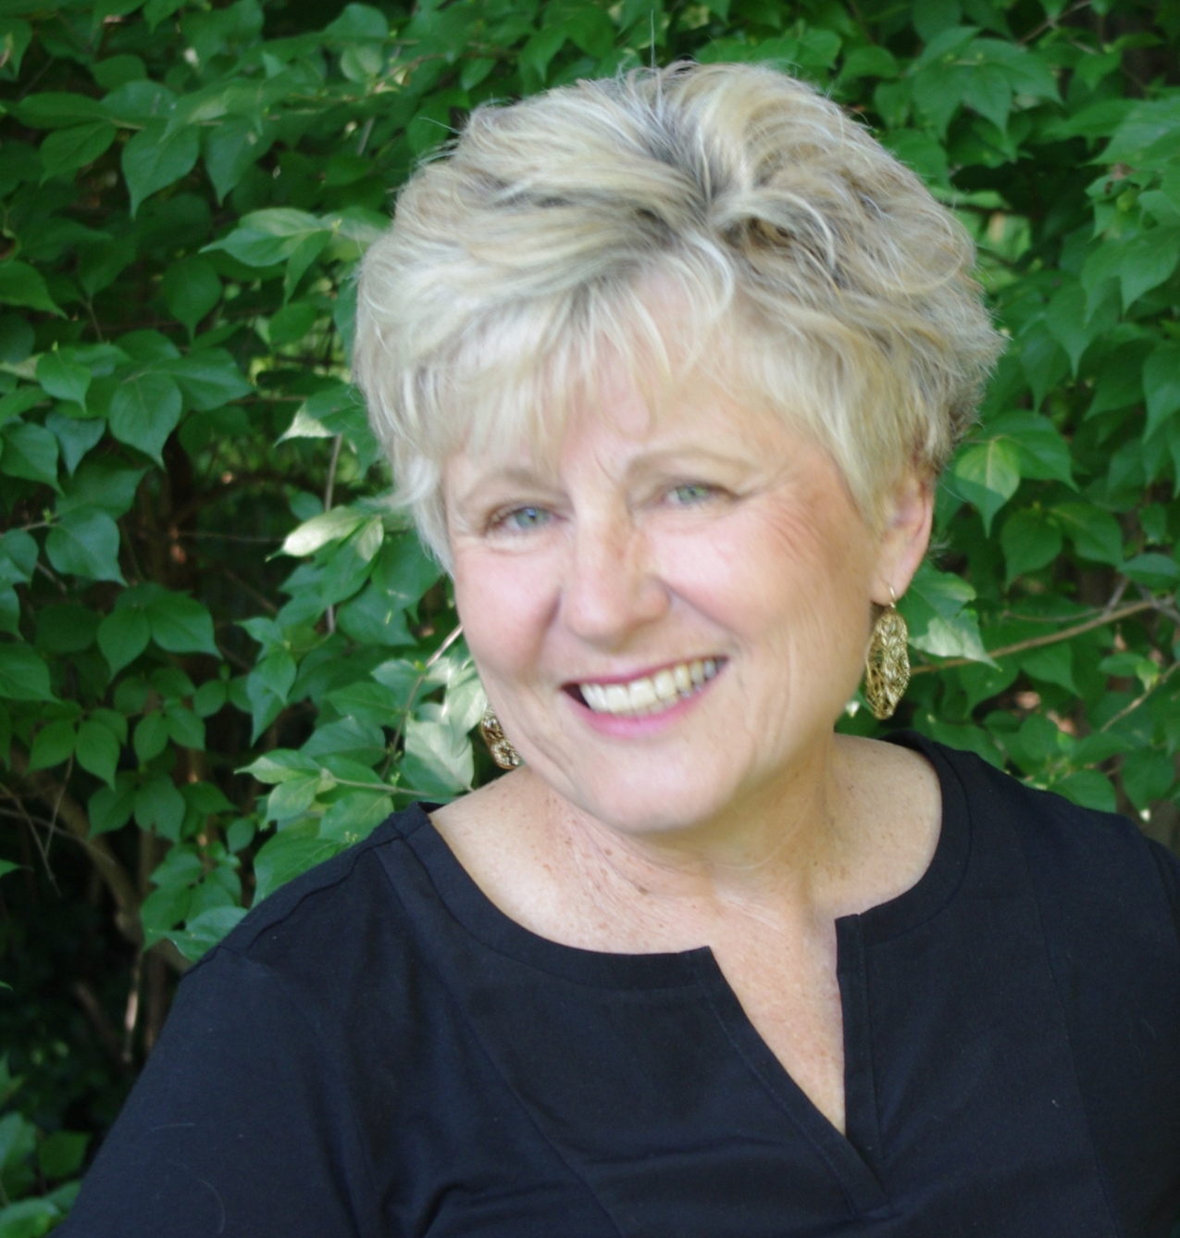
MEET ME – MRS. JILL WELSH

EDUCATION:
BS – Art Education K – 12 Life certificate
BFA – Painting and Drawing
MA – Painting
I live in St. Louis with my husband and son. I have always wanted to be one of the best art teachers in St. Louis. I am hoping your children feel the same way. I have also dreamed of becoming a famous artist with a gallery show of my own. My teacher aspiration is upon me, and I working on my art show dream. I feel lucky to have received many awards for my work in local shows.
In previous jobs, I have been awarded Teacher of the Year with Green Trails in the Parkway School, Outdoor Facilitator Trainer for the Division of Wildlife for the State of Colorado, and Member of the Teacher Advisory Group for the St. Louis Art Museum with a lesson printed on their website based upon MONET.
My hobbies include making art, hiking in the woods, gardening, and spending time with my family.

