Preschool Supplies
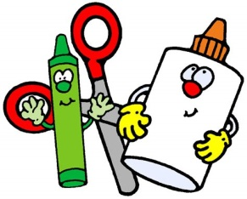

All Students
- Preschool students are required to wear uniform attire and are required to wear a closed toe shoe that has a strap in the back, preferably a tennis shoe. NO light up shoes. Your child can only wear red, white and navy blue shirts and blue, black or khaki pants or skirt/jumper.
- A back pack that a folder with two pockets will fit in to carry your child’s notes and other belongings, etc.
- A complete change of clothes (shirt, pants, shorts, underwear, socks, and a sweatshirt/sweater), in case of an accident or spill.
- Disinfecting wipes
- Paper towels
- 2 Reams of white copy paper. (20lb weight only)
- 1 Ream of color copy paper. (24lb weight only) Bright or pastel colors only. No dark colors.

Full Day Students
- A vinyl sleeping mat that is at least 1 inch thick. These can usually be bought at Wal-Mart, Target, or Amazon, where school supplies are displayed. The mat MUST be vinyl in order to be cleaned.
- A blanket and crib sheet to fit over the mat. A small stuffed animal and/or pillow is alright as long as it does not light up or make sounds/music. These will go home to be washed at the end of every week.
- A plastic tote with a lid that will fit your child’s sleeping mat and items.
- An insulated lunch bag/box with your child’s name on it.

Donations (Not required)
- Band-Aids (Any size or color)
- Hand Soap
- Ziploc Bags
- Blank Index Cards
- Tempera Paint (Any colors)

supplies preschool revised Hdrive 2019-2020

