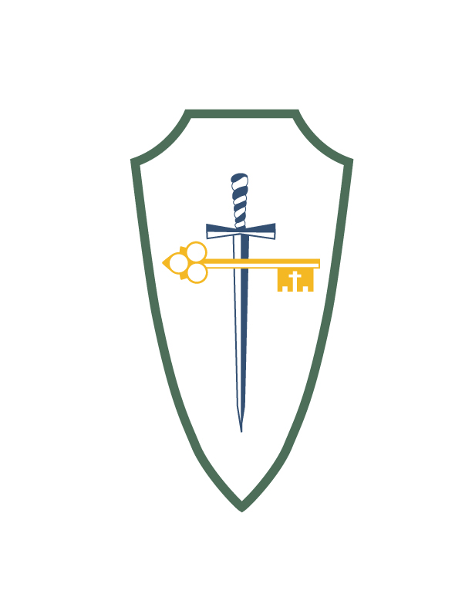Saints Peter and Paul Catholic School
2017-2018 Uniform Dress Code

Our school uniforms aid in the pride of belonging to Saints Peter and Paul Catholic School. In order to provide both formal wear to be worn on Mass days and special occasions and more casual wear for daily use, Saints Peter and Paul’s uniform consists of both a formal and a daily uniform.

The formal uniform will be worn on Mass days, special occasions, and days determined by the principal. The formal uniform will be required for boys kindergarten to 8th grade and all girls preschool to 8th grade.

Some of our students like to wear more formal wear while others more sportswear. Students are to wear the school cardigan sweater, quarter zip, or hoodie as their outer wear (School athletic hoodies may not be worn). On very cold days, a winter coat may be worn outdoors over their school outerwear.

Students, preschool to 8th grade, are to be in complete uniform beginning the first day of school.

Boys Formal Uniform (Grades K-8)
Blue pants (Docker type) worn at natural waist, properly fitting (no cargos or skinny pants)
Solid black belt with plain buckle, no wider than 2”
White oxford short sleeve or long sleeve shirt w/logo
School plaid clip-on or full necktie
Plain white undershirt
Sts. Peter & Paul outerwear: blue sweater, quarter zip, or hoodie with logo (On very cold days, a winter coat may be worn outdoors over their school outerwear.)

Boys Daily (Preschool - 8)
Blue pants (blue walking shorts may be worn during 1st and 3rd Trimesters); worn at natural waist, properly fitting (no cargos or skinny pants)
Solid black belt with plain buckle, no wider than 2” (K-8th Grade) or elastic magnetic belt (K-2)
Green polo short or long sleeve shirt with logo
Sts. Peter & Paul outerwear: blue sweater, quarter zip, or hoodie with logo (On very cold days, a winter coat may be worn outdoors over their school outerwear.)

Boys Shoes/Socks (Pre-school – 8)
Solid black shoes with non-skid soles, closed toes/closed heel (no other color on laces, soles, or logo)
White, black or navy crew type or mid-calf socks. No ankle or short socks are to be worn. No boots. On snowy days boots may be worn, but shoes must be brought to change once inside the building.

Girls Formal (Grades 6-8)
Classic Pleated Plaid Skirt (no scooters/skorts) that must measure between knee cap and 2” below the knee.
Matching shorts (solid blue or black) worn under the skirt (shorter than skirt)
On cold days plain white, black, or navy blue tights may be worn
White oxford short sleeve or long sleeve shirt w/logo
School plaid clip-on or full necktie
Plain white camisole or undershirt
Sts. Peter & Paul outerwear: blue sweater, quarter zip, or hoodie with logo (On very cold days, a winter coat may be worn outdoors over their school outerwear.)

Girls Daily (Grades 6-8)
Classic Pleated Plaid Skirt (no scooters/skorts) that must measure between knee cap and 2” below the knee.
Matching shorts (solid blue or black) worn under the skirt (shorter than skirt)
On cold days plain white, black, or navy blue tights may be worn
or navy blue pants (blue walking shorts may be worn during 1st and 3rd Trimesters); worn at natural waist, properly fitting (no cargos or skinny pants)
Solid black belt with plain buckle, no wider than 2”
Green polo short or long sleeve shirt with logo
Plain white camisole or undershirt
Sts. Peter & Paul outerwear: blue sweater, quarter zip, or hoodie with logo (On very cold days, a winter coat may be worn for outdoor over their school outerwear.)

Girls Formal (Grades Preschool- 5)
School plaid jumper that must measure between knee cap and 2” below the knee.
Matching shorts (solid blue or black) worn under the skirt (shorter than skirt)
On cold days plain white, black, or navy blue tights may be worn
Peter Pan collared white blouse (No lace, no knit)
School plaid crisscross tie
Plain white camisole or undershirt
Sts. Peter & Paul outer wear blue sweater, quarter zip, or hoodie with logo (On very cold days, a winter coat may be worn for outdoor over their school outer wear.)

Girls Daily (Grades Preschool - 5)
Girls jumper wear or navy blue pleated pants (blue walking shorts may be worn during 1st and 3rd Trimesters); worn at natural waist, properly fitting (no cargos or skinny pants)
Green polo short or long sleeve shirt with logo
Solid, black belt with plain buckle, no wider than 2” (K-5th Grade)
Green polo short or long sleeve shirt with logo
Plain white camisole or undershirt
Sts. Peter & Paul outer wear blue sweater, quarter zip, or hoodie with logo (On very cold days, a winter coat may be worn for outdoor over their school outer wear.)

Girls Shoes/Socks (Grades Preschool – 8)
Solid black shoes with non-skid soles, closed toe/closed heel (no other color on laces, soles, or logo)
White, black, or navy blue crew type, mid-calf, or knee high socks. No ankle or short socks are to be worn. No boots. On snowy days boots may be worn, but shoes must be brought to change once inside the building.

Girls Headbands (Preschool – 8)
Headbands, scrunchies and other head accessories are to match uniform colors (for example: navy blue, black, white and/or green)

**All uniform items, sweaters and hoodies are to be marked with the child's first initial and last name.

P.E. Grades 5th – 8th
Grey t-shirt w/logo
Navy blue shorts w/logo

Ordering Information-Complete Uniforms may be ordered through either of the following companies:

All Schools Apparel
7391 W. 38th Avenue
Wheat Ridge, CO 80033
(303) 424-1972

French Toast
www.frenchtoast.com
School Code: QS46E7P

