**St. John’s Lutheran School**

**Kindergarten Handbook**

**Mrs. Betty Schmitz**

**Teacher**





**CHILDREN LEARN WHAT THEY LIVE**

If a child lives with criticism,

He learns to condemn.

If a child lives with hostility,

He learns to fight.

If a child lives with ridicule,

He learns to be shy,

If a child lives with shame,

He learns to feel guilty.

If a child lives with tolerance,

He learns to be patient.

If a child lives with encouragement,

He learns confidence.

If a child lives with praise,

He learns to appreciate.

If a child lives with fairness,

He learns justice.

If a child lives with security,

He learns to have faith.

If a child lives with approval,

He learns to like himself.

If a child lives with acceptance and friendship,

He learns to find love in the world.

-Dorothy Law Nolte



**WELCOME TO KINDERGARTEN**

I am looking forward to the entrance of your child into kindergarten. I feel very excited about the upcoming school year and hope you and your child share that excitement.

Kindergarten is a very important time for you and your child. I strongly believe that a positive kindergarten experience filled with learning and enjoyment creates good feelings about school and provides a solid foundation on which their educational career may be built. Very soon the school will be entering into a partnership with you, the parents, to help provide additional experiences and aid growth and development. Close communication and cooperation between parents and teachers is vital!

The program in which your child will be involved revolves around the curricular areas of phonics, reading, math, science, social studies, art, music, and physical education. Daily activities and discussions will help your child see him/herself as a part of God’s creation, as a child of God. Each day opportunities will be provided for the child to learn while part of a large group, and teacher-directed. However, ample time will also be permitted for the child to engage in small group or individual child-directed activities. These opportunities will help to meet each child’s individual needs and help them become more independent. It is known that a child learns best through “hands-on” exploration and discovery. This is the type which I will be providing for your child.

Overall, the kindergarten program is designed with your child in mind. It focuses to meet each of their needs according to their developmental stage and past experience. I want your child to view kindergarten as a place where he/she can feel secure, make new friends, enjoy learning, understand the need to cooperate and have fun!

This booklet is for you, the parent. Its purpose is to acquaint you with our kindergarten program. It explains in detail what your child will be doing in school, and offers ways that you might contribute to their learning process. Please read carefully, and as always let me know if you have any questions.

*Mrs. Betty Schmitz*

282-6836

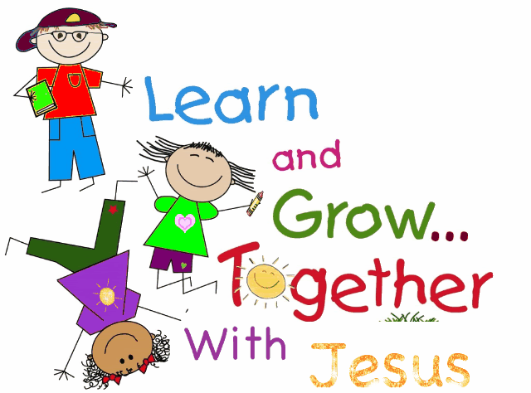

**GOALS FOR OUR PROGRAM**

* 1. To help each child understand that he/she is a child of God and loved unconditionally.
  2. To facilitate a smooth adjustment from the home to school environment.
  3. To provide an effective system of communication between school, staff, and parents.
  4. To provide a variety of experiences that will stimulate and meet the physical, social, emotional, intellectual, and spiritual needs of each individual child.
  5. To develop in every child an understanding and appreciation of appropriate behavior and self-discipline.
  6. To motivate children in development of critical and creative thinking skills.
  7. To develop in each child the ability to function responsibly and independently.
  8. To help every child develop a positive self-concept.

GROWTH AND DEVELOPMENT

When children enter kindergarten, their unique differences are very obvious. These differences are noticed in each realm of development-physical, social, emotional, spiritual, and intellectual. To help us as parents and teachers to better understand our children’s growth patterns, the St. Louis Association for the Education of Young Children has compiled a list of the characteristics to be aware of in kindergarten children.

Physically, the kindergarten child:

* Is growing more slowly than in earlier years,
* Has a tremendous drive for physical activity- running, jumping, tumbling, pulling,
* Is able to be quiet for short periods of time,
* Enjoys games with plenty of movement,
* Is more skillful at gross motor activities than fine motor activities,
* Usually has developed a hand preference by the end of kindergarten,
* Is susceptible to communicable diseases the common cold, but is beginning to build immunity.

Intellectually, the kindergarten child:

* Is active, eager, interested and curious,
* Learns by experiencing, observing, questioning, imitating, examining, exploring, and investigating,
* Derives more satisfaction from the process than the product,
* Has a growing attention span,
* Is interested in stories and books: has difficulty distinguishing between fantasy and reality,
* Clarifies understanding of relationships through dramatic play, art, movement, and construction,
* Can tell relatively long stories in sequence,
* Advances from the scribble stage to realistic figures in drawing,
* Is growing in ability to think, conceptualize,
* Solves own problems: sometimes needs adult guidance,
* Likes to finish what is started, shows sense of order in working and putting away toys and materials,
* Can continue play from one day to another.

Emotionally and socially, the kindergarten child:

* Needs to experience own success daily,
* Enjoys recognition of accomplishments,
* Gauges success or failure in terms of what the adult seems to expect,
* Needs a sense of belonging,
* Responds to praise and consistent direction,
* Thrives on trust, fairness, and achievable standards,
* Finds security in definite routine; needs to live in a reasonable predictable world,
* Is growing in emotional security,
* May begin to show rivalry,
* Has a strong emotional link with the home,
* May show fear of the new and unusual,
* Is not always able to distinguish right from wrong by adult standards,
* May cry or sulk if opposed,
* Can understand rules and accepts the consequence of breaking them,
* Has a constantly growing sense of humor; laughs at childlike jokes, silly words, unusual or unexpected sounds.
* Is serious and businesslike in play activities,
* Seeks companionship of other children; plays best in groups of two to seven,
* Is protective toward playmates and siblings,
* Chooses and changes friends frequently but as the year progresses likes to play with a constant friend.
* Needs adult help in learning to share materials, take turns, and plan activities,
* Has few adult prejudices,
* Is willing and eager to assume responsibility within own maturity level,
* Is self-centered but growing in unselfishness.

**CHURCH/SUNDAY SCHOOL ATTENDANCE**

Regular church and Sunday School attendance is an essential part of your child’s development as a child of God. It is also part of the commitment you made when enrolling your child at St. John’s Lutheran School. Children learn by the example you set for them. If attendance is important to you, it will be important to them. If you are not a member of St. John’s, attend the church of your choice- you are always welcome here. Church and Sunday School attendance slips will be attached to the Kinder news, our weekly newsletter that is sent home on Fridays. Please fill the slip out and return it on Monday.

**LIBRARY**

We have a very well-stocked library in our classroom. Your child will be able to check out one book at a time. The book will come home in a special “Library Bag”. Read and reread the book with your child. Books will be checked out for one week or less. Return the book in the “Library Bag” as soon as you are done with it. I require that a book should be returned before a new one may be checked out. Record books that you read on the reading sheet. When the sheet is full, send it to school so that your child may choose a treasure from the Treasure Box.

**DRESS CODE**

Our School Handbook addresses our school dress code. The following are areas of special concern for Kindergarteners: Students may not wear flip-flops or sandals to school. I recommend that your child wear sneakers or tennis shoes to school. They will also need a pair of tennis shoes that will be left at school to wear in the gym for recess or P.E. Clothing should be clean and without holes. No spaghetti straps or tank tops may be worn unless they are covered by a shirt. I also recommend that girls wear shorts under dresses or skirts. No body art (tattoos) may be worn to school.

**HEALTH**

**SICKNESS AND ILLNESS:**

-Please do not send your child to school if they are showing any one of these signs of illness:

Fever – Your child must be fever FREE for 24 hours before returning to school.

Earache

Swollen glands

Vomiting

Diarrhea

Sore throat

Or other communicable disease

-Absence or illness of your children must be reported to the school office. St. John’s Lutheran School 282-3873.

-If your child is not to participate in physical activities or outdoor play, please send a note from home stating that fact.

**HEALTH HABITS TO ESTABLISH:**

-See that your child gets plenty of rest – set a bed time.

-Give them a good breakfast.

-Teach them to brush their teeth.

-Teach them to wash their hands before eating.

-Teach them to cover their mouths when coughing or sneezing.

-Teach them to keep fingers and objects out of their mouths.

-Dress your child for the weather.

-Teach them to use a drinking fountain and restroom facilities correctly.

The following pages are an overview of the areas of learning that we will be covering this year:

**GOD’S WORD**

**Your child will…** **Experience provided at school…**

Worship each day through song Daily worship time

and prayer

Learn about Jesus through Bible Jesus time stories

stories

Make simple arts/crafts projects School chapel once a week

to remind them of Jesus’ love

Puppets

Leading chapel as a class during the year

**HOW PARENTS CAN HELP…**

Share with your child how God’s love lives in your life.

Attend church regularly.

Attend Sunday School/Bible class regularly.

Have a daily family devotion and prayer time.



**LANGUAGE ARTS – READING – WRITING – PHONICS**

**Your child will… Experiences provided at school…**

Listen to stories Saxon Phonics

Tell stories about pictures A Reason for Handwriting

Learn to understand and follow directions Library Center

Learn to rhyme Daily story time

See likeness and differences in Child-made books

pictures and words

Learn letter names and sounds Dramatic Play area

Listen for sounds at beginning Library Visits (weekly)

and ending of words

Learn to blend sounds Sharing time (to tell about personal experiences)

Establish left to right sequences Student journals

Learn sight words and read simple sentences Writing Center

Display a good growing vocabulary

**HOW PARENTS CAN HELP…**

Read to your children on a daily basis. Set a good example by showing how much

you enjoy and profit from reading.

Look at picture books with them .

Praise them when they share by reading or

Let them tell the story and their showing their books or project to

ideas about the pictures. someone else.

Give directions only once! Try **Take time to review daily work coming**

not to repeat. **home, and give extra practice**

**when needed.**

Encourage them to express themselves

orally, but discourage baby talk.

**MATH READINESS**

**Your child will… Experiences provided at school…**

Count by 1s, 5s, 10s Calendar Time at SMART Board

Read and write numbers to 30 Go Math!

Compare and order numbers to 20 Learn to write an addition sentence

Identify most, fewest, more, less Learn to write a subtraction sentence

Recording daily calendar changes Informal daily counting

Act out story problems Counting chart

Use concrete and pictorial models for Games

addition, subtraction

Read and present time to the hour Shape, Color and Number bingo

Measure using non-standard units Graphs and Charts

Identify and count pennies, nickels, dimes, quarters

Show an amount of money using coins

Write money amounts using a ¢ sign

Identify shapes and patterns

Compare and order objects by length

Identify days of the week and months of the year

**HOW PARENTS CAN HELP…**

Use number situation at home (setting Count with your child.

the table, counting objects,

identifying house numbers, etc.) Measure how tall your child is as well as

other things around them.

Observe shapes and patterns in the

everyday world. Review money and time concepts when

possible.

Mark important dates on the calendar

with your child.

**HANDWRITING**

At school your child will be learning to use the style of the letters shown below. You can help them with this task by letting them practice at home.

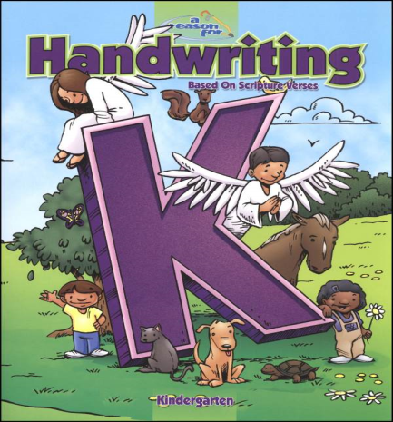

**SCIENCE**

**Your children will…** **Experience provided at school…**

Develop an interest in discovering Recording activities in a log book

Learn to make predictions

Learn to make comparisons Plants

Learn to appreciate nature Experiments

Learn to distinguish between living Pictures and discussions

and non- living things

Come to understand weather and Group project for school Science

seasons and how they affect our Fair

living habits

Become aware of earth’s neighbors,

(Sun, moon, sky, space)

Identify basic parts of the human body

**HOW PARENTS CAN HELP…**

Take walks with your children

Encourage them to experiment with new “safe objects and substances”

Answer curious questions

Allow them to assist you in baking or cooking



**SOCIAL STUDIES**

**Your child will… Experiences provided at school…**

Develop a positive self concept Holiday observance

Identify family members and their roles Daily recitation of the pledge

Observe classroom rules Field trips

Respond appropriately to fire, tornado & lock

down evacuation drills. A warm and secure environment

Discover and discuss our many emotions Globes and maps

Identify community workers and their roles Fire and tornado safety discussions and

and drills

Explain how people are alike and different A warm and secure environment

Understand the reasons for various holidays

Be introduced to a globe and what it represents

**HOW PARENTS CAN HELP…**

Be good role models. Explore the community with your children.

Help children to become aware of the Give them opportunities to follow

two basic emotional needs, love directions independently.

and security.

Help children to find acceptable ways to

release emotions.



**MUSIC**

**Your child will… Experiences provided at school…**

Learn to sing with a pleasing Actions songs/dances

tone (inside voices)

Sing simple songs/rhymes by rote Jesus time songs

Participate in musical games Bells

Perform bodily movements in time School Choir (K-2)

with various tempos

Learn to enjoy musical activities School Christmas Service and Spring Musical

Listen to different types of music School Choir (K-2)

Learn to identify several rhythm instruments

Sing increasingly louder or softer as

the music dictates

**HOW PARENTS CAN HELP…**

Provide musical experiences for your children Take time to listen to your children

at home through children’s CDs. when they want to share a

a new song or dance with you.

Be good models by showing your own

appreciation and enjoyment

through music.



**ART**

**Your child will… Experiences provided at school…**

Identify the eleven basic colors Drawing

Identify the basic geometric shapes Easel painting

Work independently on art projects Playdough

Express themselves with various media Paper projects

(paint, paper, glue, etc.)

Be able to use a scissors with a reasonable Marker projects

amount of accuracy

Show satisfactory eye-hand co-ordination Watercolor paintings

in the use of media and tools

Develop skills in working together on

group art projects

**HOW PARENTS CAN HELP…**

Encourage your children to draw and Assist your children in learning how to

color pictures. hold a scissors and cut properly.

Encourage your children to cut and paste. Encourage your children to experiment

and be creative.

Provide different medias (paint, markers, Allow them to trace around objects.

Play dough, etc.)



**PHYSICAL EDUCATION**

**Your child will… Experiences provided at school…**

Demonstrate adequate eye-hand Circle games

and eye-foot coordination

Participate in games for enjoyment Ball skills

Learn how to run relays Locomotor movements

hopping, skipping,

Play simple games in which rules are galloping, etc.

to be followed and good

sportsmanship is demonstrated Balancing

Express themselves during creative Jump rope activities

movement

Maintain balance in various positions Parachute play

or while moving

Discriminate between left and right Non-locomotor movements

Bending, twisting,

Relays Stretching, etc.

**HOW PARENTS CAN HELP…**

Provide opportunities for your children Play games or provide activities which

to play games both indoors and require the use of their large

outdoors. muscles (ball throwing, jumping,

skipping, etc.)

Take time to participate in games with Encourage good sportsmanship.

your children.