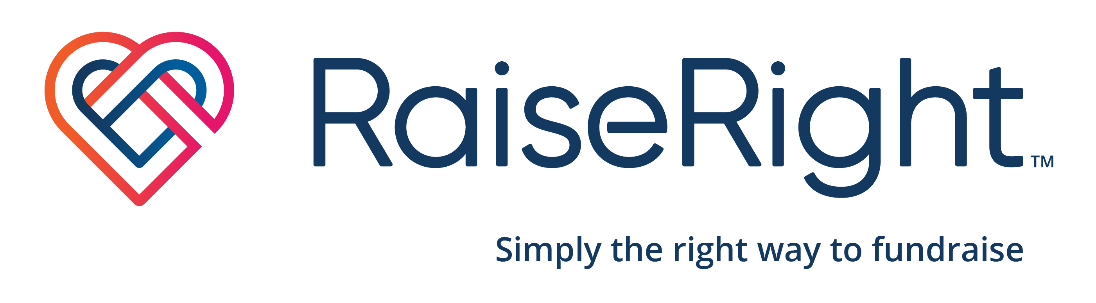

Who?
All STM families! Each family is required to purchase $3000 each year in SCRIP.

What is Scrip?

SCRIP is a fundraising program where you simply purchase actual or electronic gift cards that are used just like cash. You pay nothing extra! Purchasing a $25 certificate to a participating merchant allows you to buy $25 of merchandise, and these merchants give a portion back to St. Mary’s! By utilizing scrip, we earn money for St. Mary’s school without spending an extra penny!

Where can I use Scrip?

Many vendors participate in the scrip program- including grocery stores, restaurants, gas stations, pharmacies, and more!

How do I get started?

There are many easy ways to purchase scrip!
- Create a RaiseRight account to purchase electronically- visit https://www.raiseright.com/enroll?enrollCode=63BBEA4D3539 or use the QR code below.
- Scrip tables will be set up after many Masses - use cash or a check to purchase in-stock gift cards.
- Come by the school office anytime (8-2, M-F when school is in session) to purchase in-stock gift cards.
- Send an order form (on the PTC planner page) to school with your child. Gift cards will be sent home with your student on Friday.

Where do the profits go?
Last year St. Mary’s profited over $15,000 from the SCRIP program! Scrip profits help support PTC initiatives. Key initiatives from the last year include repairing the HVAC system for the older grades, purchasing new preschool playground equipment, and purchasing new Math textbooks.

Questions?

Please contact Aggie Menner via FastDirect.
