
Parent Activation} Step by Step Instructions
Trinity Lutheran School
Welcome! We’re excited to introduce you to your FastDirect service, a
powerful system designed to help you connect with your school. Please
follow the instructions listed below in order to activate your account.

Name: Activation Code:

Step 1: Connect to the Internet.
Step 2: Go to your login page by typing the following URL (website address) into the address bar (NOT the search field):
http://www.fastdir.com/trinitybrillion
*The URL is case sensitive and should be typed exactly as displayed above.
Step 3: On the left side of the login page, please click on the link titled, Parent Activation. Complete the form (see sample form below) using the activation code that was provided by the school office.
Step 4: Click the ‘Submit’ button to send the information to FastDirect.
Step 5: Within 24 hours, our HelpDesk (fastdirectnotification@fastdir.com) will send you an e-mail with the subject title, FastDirect School Parent Activation. This important e-mail contains your temporary screen name and password so that you may log on to your school’s FastDirect site.

Sample Parent Activation Form:
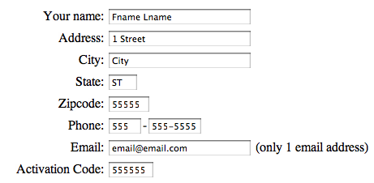
HELPFUL TIPS:
- You will NOT receive a screen name and password, if the activation form
(like the example above) is not completed or does not match the information
on school record.
- To help ensure delivery of our confirmation e-mail, please add our address (fastdirectnotification@fastdir.com) to your contacts.
- If you still do not receive our confirmation e-mail within 24 hours, please contact your school office.

Thank you for using FastDirect to strengthen your school community. We
hope you enjoy the enhanced connection between your family and school.
Sincerely,
The FastDirect Team

